**Major Project Report**

**On**

**“Health Harmony Based on Fitness Web-Site”**

**Submitted for partial fulfillment of the requirment for the**

**Award of the degree**



**Bachelor of Computer Science and Engineering**

**Future Institute of Engineering & Technology,**

**Bareilly**

**Of**

**Computer Science and Engineering**

**By**

**Vipin Kumar (2004760100095)**

**Yashvardhan Saxena (2004760100099)**

**Narendra Yadav (2004760100095)**

**Harish Rawal (2004760100040)**

**Under the guidance of**

**Mr. Abhishek Saxena (HOD CSE)**

**Mr. Sachin Raj Saxena**

**(Assistant Professor)**

**Department of CSE**

**TABLE OF CONTENTS**

* **Introduction to the Project**
* Transformation of manual systems to automated software systems
* Benefits of computerization: reduced errors, time-saving, and efficient report generation
* Project Name: Health Harmony
* Project Modules: Registration, Login, About, Contact Us
* **Objectives**
* Overview of Health Harmony's purpose
* Objectives of the project: User-friendly interface, detailed exercise explanations, video demonstrations of workouts, personalized diet plans, easy user registration
* **Need of the Proposed System**
* Performance
* Control
* Security
* **Problem Definition**
* Shortcomings of existing manual systems
* Need for a user-friendly, GUI-oriented computerized system
* Features: Stock reports, stock edits and deletions, adding new items, security and user-level access, reliability, availability, maintainability, configuration and compatibility
* **System Requirements**
* Hardware: Processor: Intel i3, Hard Disk/SSD: 1GB, RAM: 4GB, Colored Monitor
* Software: Frontend: HTML, CSS, JavaScript, Bootstrap, IDE: Visual Studio Code, SQL Server Management Studio (SSMS), ASP.Net MVC, Entity Framework, LINQ
* **Technical Overview**
* .NET Framework: Overview and advantages, supported programming languages, cross-platform capabilities
* HTML & CSS: HTML structure and elements, CSS syntax and selectors, example HTML and CSS documents
* JavaScript: Overview and history, client-side JavaScript, integration with HTML
* SQL Server: Overview and history, features and editions
* **System Design and Development**
* Analysis and Design: Existing system: manual record-keeping, proposed system: digital and integrated solution
* Functional Specifications: Description of software features and behavior, technical design information
* Feasibility Analysis: Technical feasibility, operational feasibility, economic feasibility
* **Health Harmony System Management**
* Complete Module of the Project: Detailed module descriptions and functionalities

**INTRODUCTION TO THE PROJECT**

**INTERODUCTION:-**

More and more manual systemsare being transformed into automated computer software systems.This not only reduces the amount of hard work and timeconsumed in manual system ,the computerization also minimizes the errors in calculations and report genration**.**

The name of our project is **Health Harmony.**

This project is Modulized as the following:

Registration

Login

About

Contact Us

**OBJECTIVE**

We know that getting to the gym isn't always possible for everyone. That's why we created Health Harmony, a website designed to help you achieve your fitness goals from the comfort of your own home.

The objectives achieved by the **Health Harmony** project are :-

* User-friendly interface
* Detailed explanations of exercises
* Video demonstrations of workouts
* Personalized diet plans
* Easy registration for new users

**NEED OF THE PROPOSED SYSTEM**

We designed Health Harmony using the .NET framework with ASP.NET to help you achieve your fitness goals. This system is perfect for those who can't make it to the gym. You can perform exercises at home, with or without equipment, targeting specific body parts like your chest, arms, and legs.

Here's why our system is essential:

* **Performance**:-

In the past, many people were unaware of health and fitness or couldn't access gyms due to a lack of knowledge or equipment. Health Harmony is a comprehensive solution that provides everything you need to stay fit.

* **Control**: -

Only authorized users with the correct password can access the project, ensuring complete control and preventing unauthorized access.

* **Security**:-

Security is a top priority for our system. Unauthorized access is strictly prohibited, making security a key feature of Health Harmony.

**PROBLEM DEFINITION**

Identifying the shortcomings of the existing system has led us to design a more user-friendly and GUI-oriented computerized system that seamlessly integrates with the current system. This new approach aims to improve efficiency and overcome the limitations of the existing system.

Our project focuses on managing information such as stock reports, stock edits, stock deletions, and adding new items.

**Security**

We have implemented project-level security where users need to log in at the start of the program. There is an option to create additional users and implement user-level security. While user-level security isn't currently set up, it can be added with a few modifications.

**Reliability, Availability, Maintainability**

Our software is user-friendly, secure, and requires minimal maintenance. It can be upgraded step-by-step according to requirements.

**Configuration and Compatibility**

The software can be customized and configured to meet individual user or organization needs, ensuring smooth operation and compatibility with existing systems.

**SYSTEM REQUIREMENTS**

**a : Hardware Requirements:**

* Processor : Intel i3
* Hard Disk/SSD :1GB
* RAM : 4 GB
* Coloured Moniter

**b : Software Requirements:**

* Frontend : HTML,CSS,Javascript,BOOtstrap.
* IDE : Visual studio code,SQL Server Manegement studio (SSMS)
* ASP.Net MVC
* Entity Framwork
* linq

**DOT NET**

.NET is a versatile and robust framework created by Microsoft, designed to facilitate the development of a wide array of applications, from web and mobile to desktop and cloud-based services. It provides a consistent programming model and a rich library of pre-coded solutions, enabling developers to concentrate on building efficient, innovative, and reliable applications.

Supporting multiple programming languages such as C#, F#, and Visual Basic, .NET offers the flexibility to choose the best language for your project. Its cross-platform capabilities ensure that .NET applications can run on Windows, macOS, and Linux, broadening your software's reach. Additionally, the thriving .NET community is always ready to assist, share knowledge, and contribute to a constantly evolving ecosystem.

Whether you're an experienced developer or just beginning your journey, .NET equips you with the tools and support necessary to transform your ideas into scalable, maintainable, and dependable applications.

**HTML & CSS**

**Hypertext Markup Language(HTML)** is the standered markup languagefor creating web pages and web applications with Cascading Style sheet(CSS) and javascript in form a traied ofcommoerstone technology for the world wide web. Web browsers recive HTML document form a web server or from a local storage and render them intomultimedia web pages.

HTML elements are the building blocks of HTML pages. With HTML constructs, images and other objects,such as interactive form, may be embeded into the render page.

HTML elements are delinedted by tags,written written using brackets tags such as <img/> and <input introduce content into the page directly..Other such as <P>…</P> surround and provide information aboutdocument text and may include other tags as sub-elements.

* HTML is standered markup language for creating the web page.
* HTML standes for Hyper Text Markup Language.
* HTML elements are the building blocks of HTML pages.

**A Simple HTML Document:-**

<html>

<head>

<title>HTML page</title>

</head>

<body>

<h1>THIS IS FIRST HTML PAGE</h1>

</body>

</html>

**HTML ELEMENTS**

HTML documents are structured using nested HTML elements. These elements are indicated in the document by HTML tags, which are enclosed in angle brackets, like this: <p>.

In general, an element's extent is marked by a pair of tags: a "start tag" <p> and an "end tag" </p>. Any text content of the element is placed between these tags.

Tags can also contain further tag markup between the start and end tags, including a mixture of tags and text. This indicates nested elements, as children of the parent element.

The start tag may also include attributes within the tag. These provide additional information, such as identifiers for sections within the document, identifiers used to bind style information to the presentation of the document, and references for resources like images.

Some elements, like the line break <br>, do not allow any embedded content or further tags. These require only a single empty tag, which acts as a start tag, and do not use an end tag. ​

**Introduction to CSS (Cascading Style Sheets)**

Cascading Style Sheets (CSS) is a style sheet language used to describe the presentation of a document written in HTML or XML (including XML dialects such as SVG, MathML, etc.). CSS describes how elements should be rendered on screen, in print, or even spoken aloud. It controls layout, colors, fonts, and other visual aspects of a webpage, making it an essential component of web development.

Basic Syntax of CSS

CSS consists of a set of rules that define the styling properties for various elements on a webpage. Each rule consists of a selector and a declaration block. The selector indicates which HTML elements the rule applies to, while the declaration block contains one or more declarations separated by semicolons.

Example:

css

Copy code

/* CSS Comment */

selector {

property: value;

}

**Selectors:-**

Selectors are patterns used to select the elements you want to style. They can target HTML elements, classes, IDs, attributes, or even specific elements based on their relationship with other elements

Element Selector: Selects all instances of a specified HTML element. Example:

p {

color: blue;

}

**Class Selector:-** Selects elements with a specific class attribute.

.highlight {

background-color: yellow;

}

**ID Selector:-** Selects a single element with a specific ID attribute.

#header {

font-size: 24px;

}

**Properties and Values :-** CSS properties define the visual appearance of elements, such as color, size, font, etc. Each property accepts one or more values, which determine how the property should be applied.

**Cascading and Specificity**

CSS follows a set of rules to determine which styles should be applied when there are conflicting rules. This process is known as cascading. Specificity is the means by which browsers decide which CSS property values are the most relevant to an element and, therefore, will be applied.

Inheritance: Some CSS properties are inherited from parent elements to their children, while others are not.

Specificity: It's a measure of how specific a selector is. The more specific a selector, the higher its precedence.

Cascade: When multiple CSS rules apply to the same element, the most specific rule takes precedence, followed by the order of appearance inthe stylesheet.

Example:-

<!DOCTYPE html>

<html>

<head>

<title>CSS Example</title>

<link rel="stylesheet" type="text/css" href="styles.css">

</head>

<body>

<div id="container">

<h1 class="header">Welcome to CSS Example</h1>

<p>This is a paragraph.</p>

<p class="highlight">This is a highlighted paragraph.</p>

</div>

</body>

</html>

**And the associated CSS file (styles.css):-**

.header {

color: blue; /* Applied to all headers */

}

#container {

background-color: #f0f0f0; /* Applied to the container */

}

p {

font-family: Arial, sans-serif; /* Applied to all paragraphs */

}

.highlight {

background-color: yellow; /* Applied only to paragraphs with class "highlight" */

}

**JAVA SCRIPT**

JavaScript is a lightweight, interpreted programming language, perfect for creating dynamic web applications. It's designed to work seamlessly with Java, and it's tightly integrated with HTML, making it very user-friendly. Plus, it's open and works across different platforms.

Originally known as Live Script, it was renamed JavaScript by Netscape, partly due to the buzz around Java at the time. JavaScript made its debut in Netscape 2.0 back in 1995 as Live Script. Over time, it has become an essential part of web development, embedded in browsers like Netscape, Internet Explorer, and others.

**Here are some key points about JavaScript:**

* Lightweight and interpreted: It's quick and easy to implement.
* Network-centric applications: Ideal for creating interactive web pages.
* Integration with Java: Complements Java seamlessly.
* Integration with HTML: Works hand-in-hand with HTML.
* Open and cross-platform: Available for use across various platforms.

**Client-side JavaScript:**

Client-side JavaScript is the most common version of the language. It's included in or referenced by an HTML document, allowing the code to be interpreted by the browser.

This means your web pages don't have to be static; they can include programs that interact with users, control the browser, and dynamically create HTML content.

Using JavaScript on the client side offers many advantages over traditional CGI scripts. For example, you might use JavaScript to verify if a user has entered a valid email address in a form field, making web interactions smoother and more efficient.

**About SQL Server**

SQL Server is Microsoft's relational database management system (RDBMS). It's a comprehensive database designed to compete with heavyweights like Oracle Database and MySQL.

Supporting all major RDBMS standards, SQL Server is compatible with ANSI SQL, the standard SQL language. Additionally, it features T-SQL, its own SQL implementation, and SQL Server Management Studio (SSMS), a main interface tool previously known as Enterprise Manager. It works in both 32-bit and 64-bit environments.

Often referred to as MSSQL or Microsoft SQL Server, it first appeared in 1989 as version 1.0, developed by Microsoft in partnership with Sybase. Initially, SQL Server resembled Sybase a lot. However, the partnership ended in the early 1990s, and Microsoft took full control of SQL Server, rebranding it under its own name. Since then, Microsoft has rolled out various versions, including 2000, 2005, and 2008, each with enhanced features and improved security.

Some standout features include support for XML data types, dynamic management views (DMVs), full-text search capability, and database mirroring.

SQL Server comes in several editions, each tailored to different needs and budgets:

**Enterprise**: Ideal for large enterprises with complex data requirements, including data warehousing and web-enabled databases. It includes all features of SQL Server, making it the most expensive option.

**Standard**: Geared towards small and medium-sized organizations, it also supports e-commerce and data warehousing.

**Workgroup**: Perfect for small organizations, with no size or user limits. It's suitable for backend databases for small web servers or branch offices.

**Express**: Free to use, with fewer features and database size limitations. It's a great replacement for an Access database.

**Analysis and Design**

**Existing System:**

Currently, all records are maintained manually. This is just the initial step towards digitizing the entire process.

**Proposed System :**

The new system aims to streamline daily operations, making them smoother and more efficient. It will integrate different modules to meet the organization’s needs.

**Functional Specifications :**

Functional specifications are created after defining the software requirements. They provide detailed descriptions of selected items, originally outlined in the software requirements document. Some software development teams combine these documents into one.

The functional specification outlines the software's features. It describes how the software should behave from an external perspective and includes technical information necessary for the design. This specification defines what the functionality will be, but not how it will be implemented.

Software engineers use the functional specification to create a detailed design document. This document elaborates on how the software will be designed and developed. Detailed design work may break down and translate functional requirements into pseudocode, which is then turned into a computer module or program.

The functional specification translates the software requirements into a technical description that:

Ensures that the product feature requirements are correctly understood before moving to the next step, the software design process.

Clearly and unambiguously presents all the information needed to design the software.

**Feasibility Analysis**

**Technical Feasibility :-**

The project employs well-established technologies (ASP.NET, SQL Server, HTML/CSS/JavaScript), ensuring reliable development and maintenance. The technical requirements are within the capabilities of modern hardware and software environments.

**Operational Feasibility :-**

The user-friendly interface and comprehensive features (exercise demos, diet plans) ensure easy adoption by users. The project addresses a real need for accessible fitness solutions, enhancing its operational feasibility.

**Economic Feasibility :-**

The primary costs involve development tools and resources, which are standard in software development projects. The potential market for online fitness solutions suggests a strong return on investment.

**HEALTH HARMONY SYSTEM MANAGEMENT**

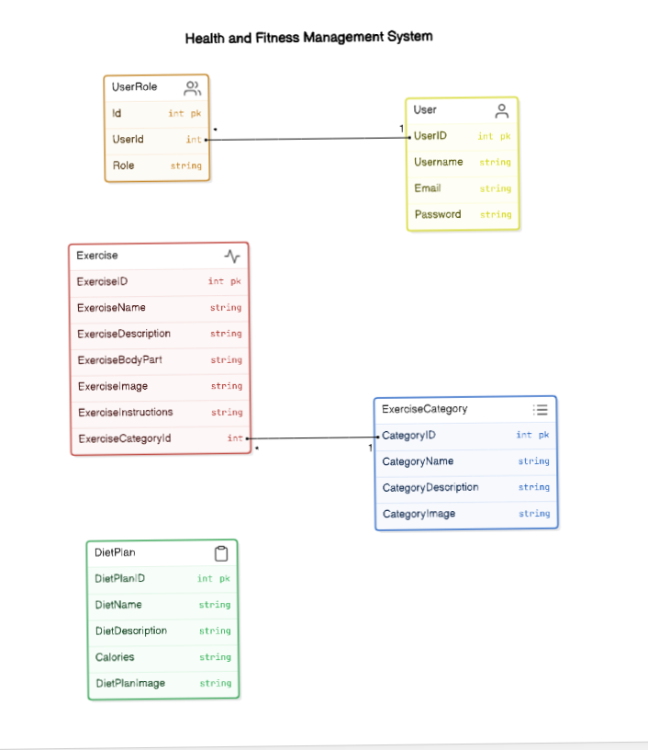

**COMPLETE MODULE OF THE PROJECT**

**Exercise Category Controller**

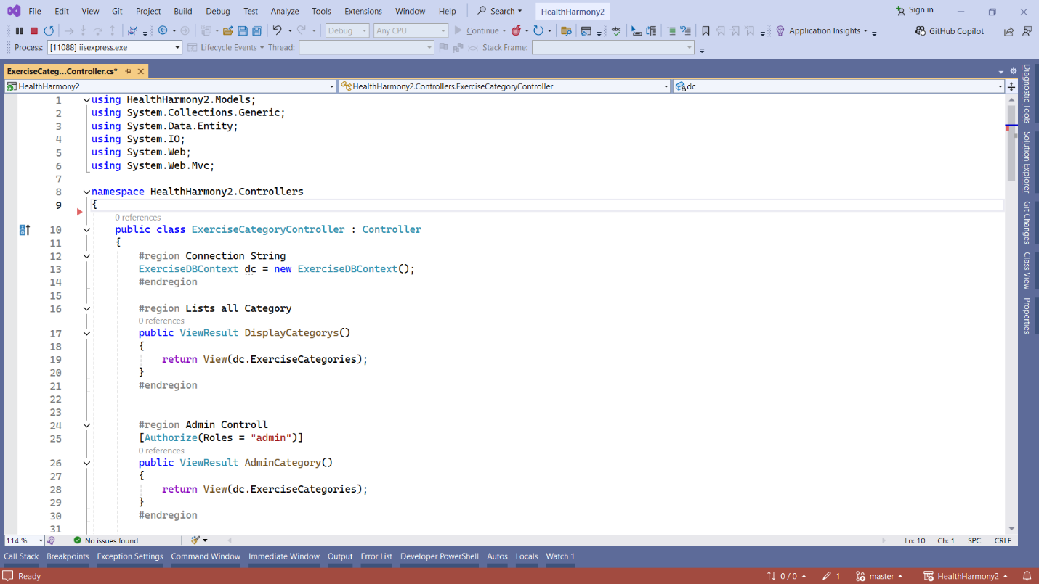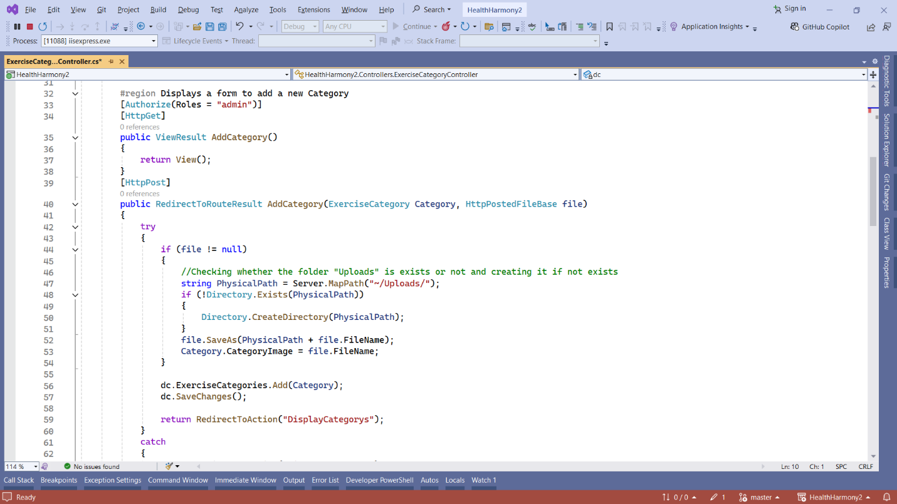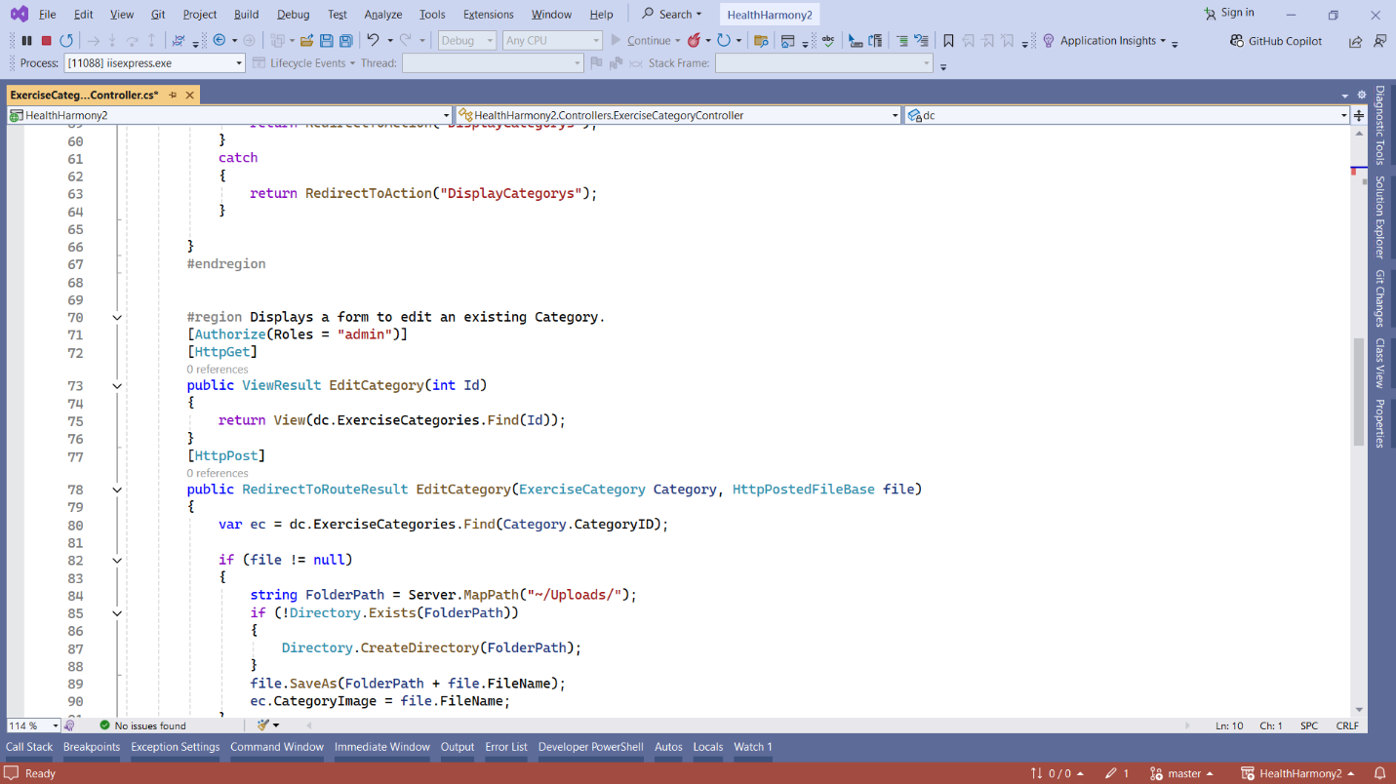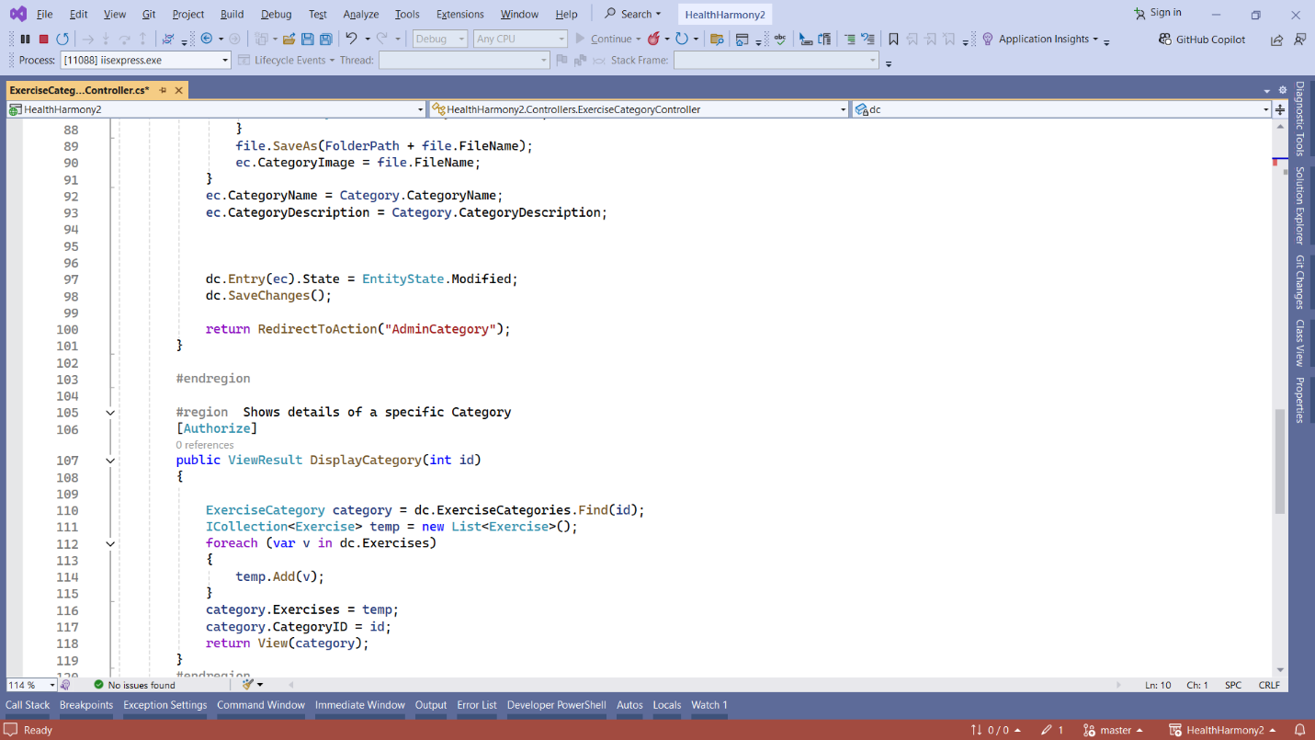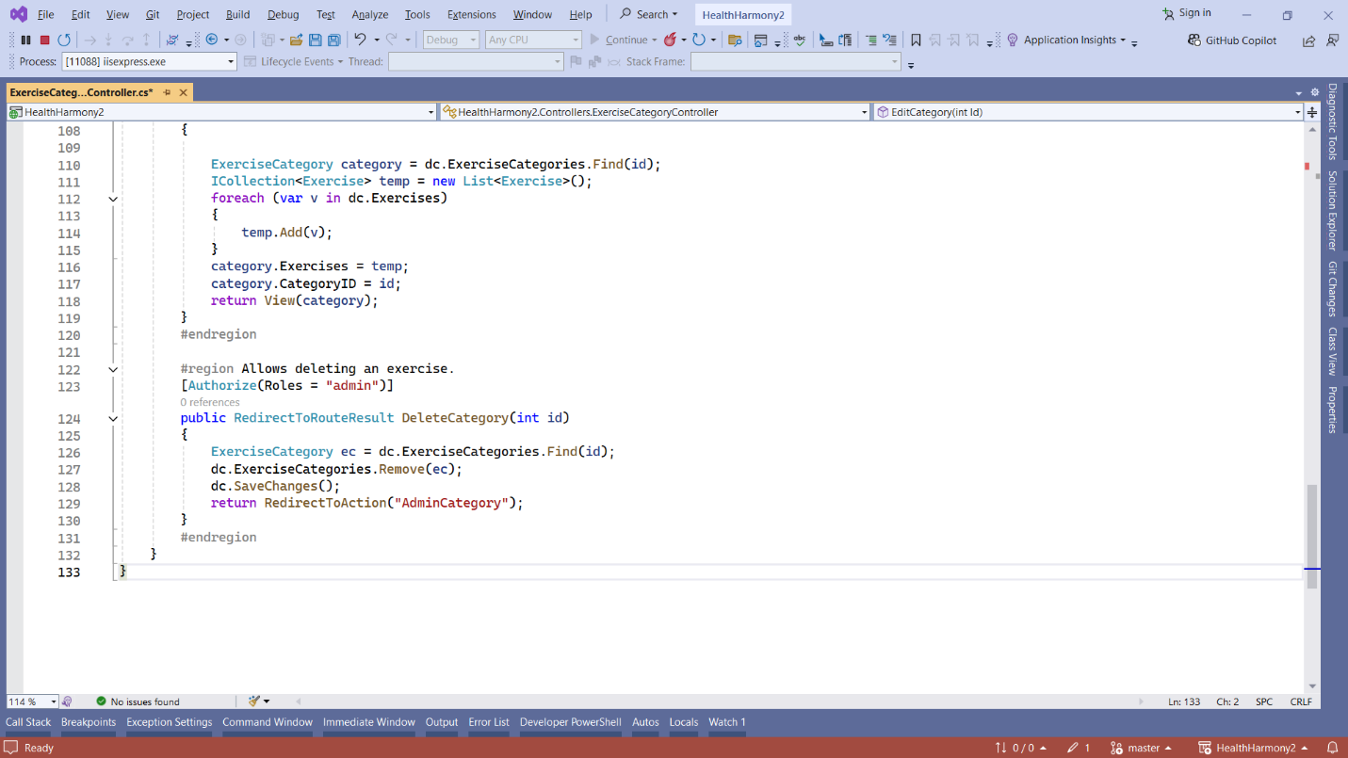

**Exercise Category Model Class**

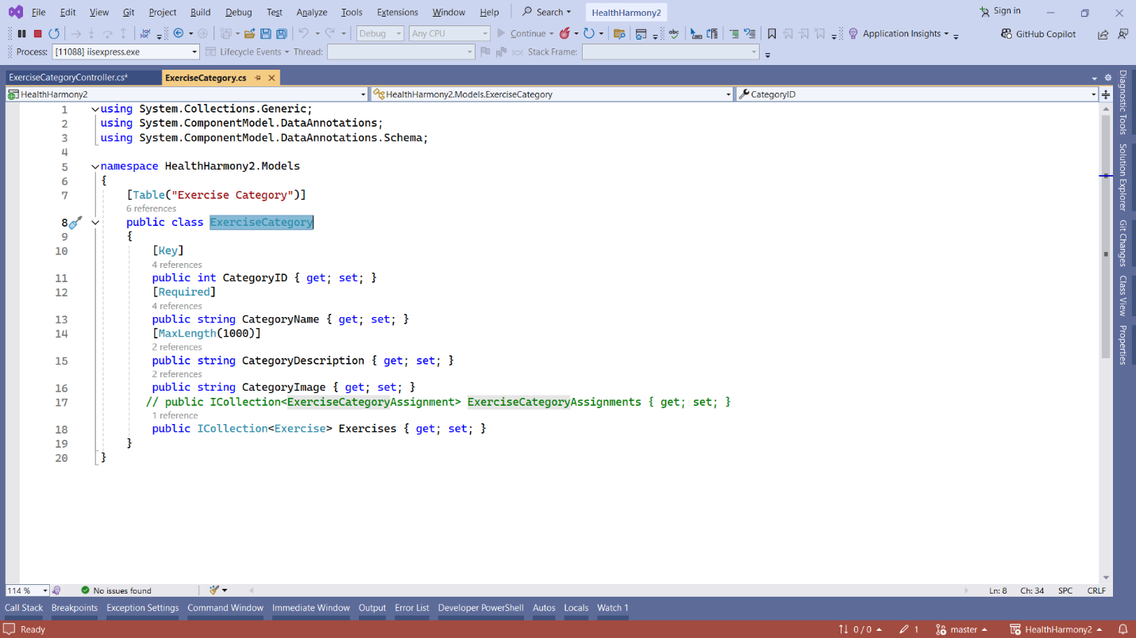

**Display Categorys Views**

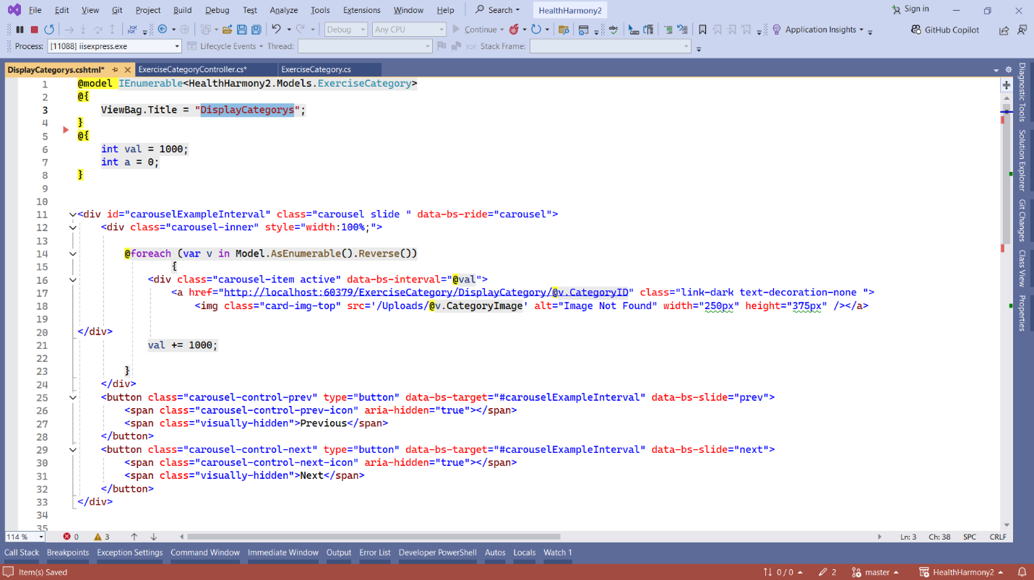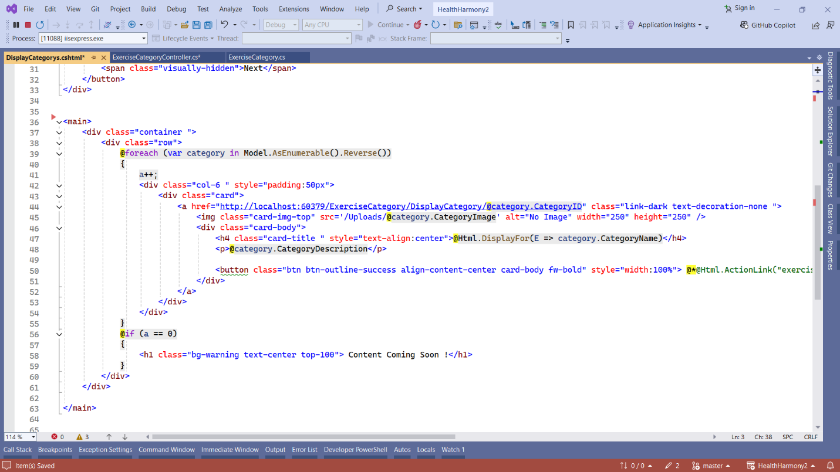

**OutPut**

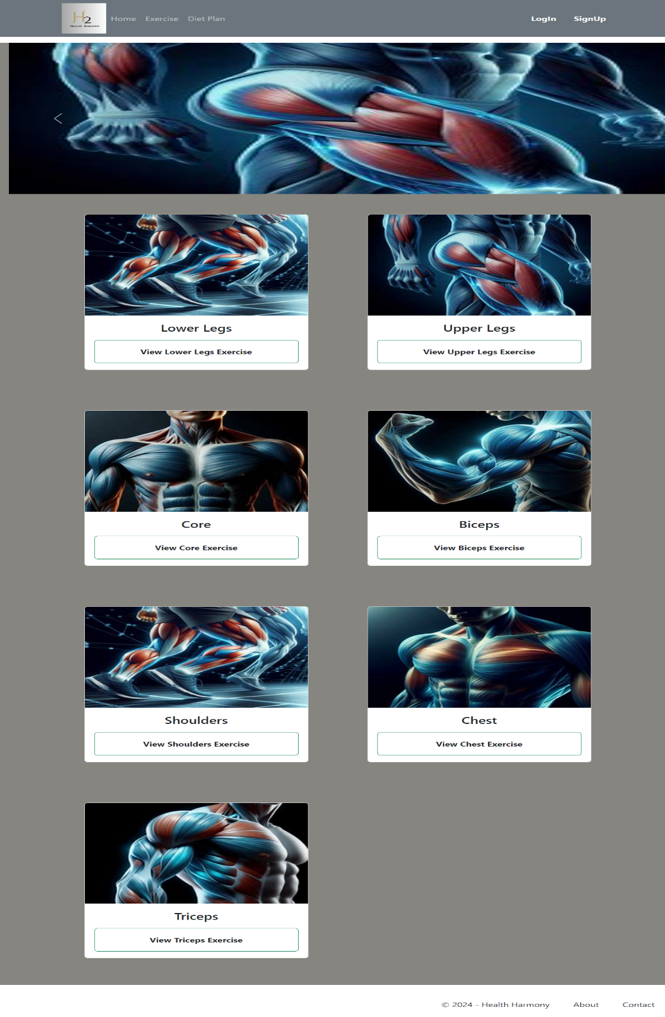

**Edit Category View**

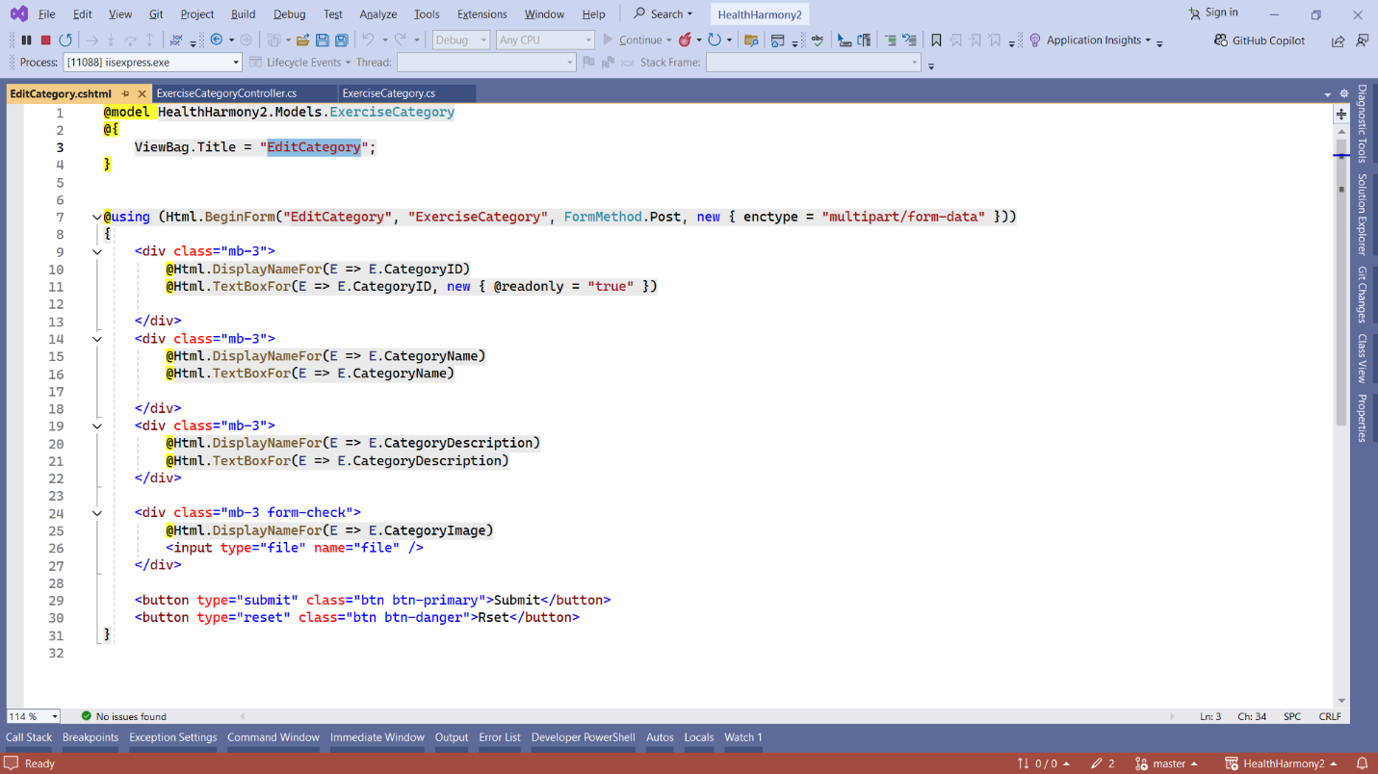

**OutPut**

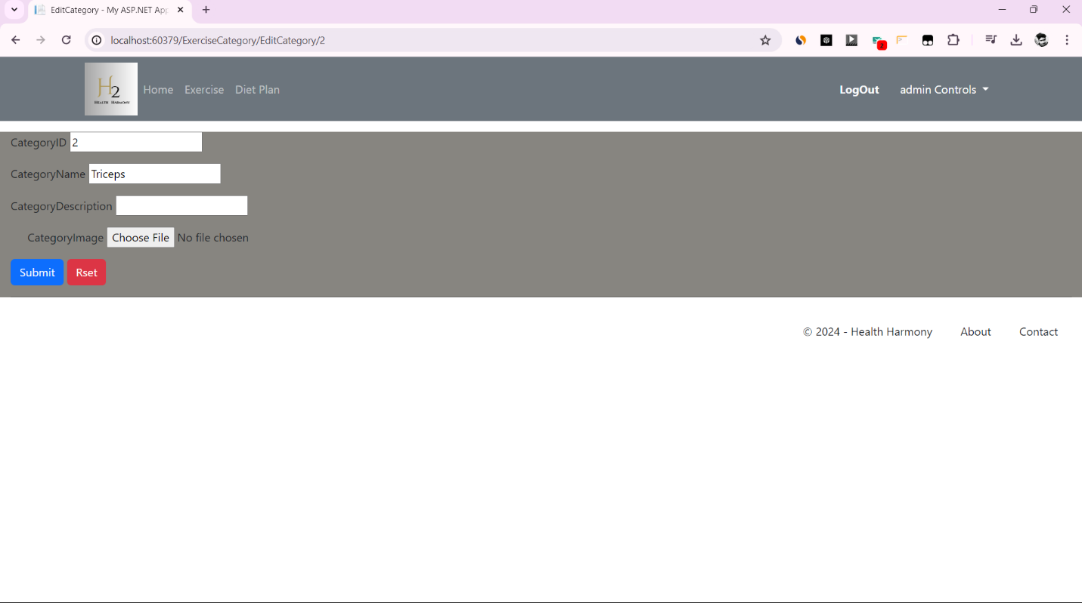

**Display Exercise by Category**

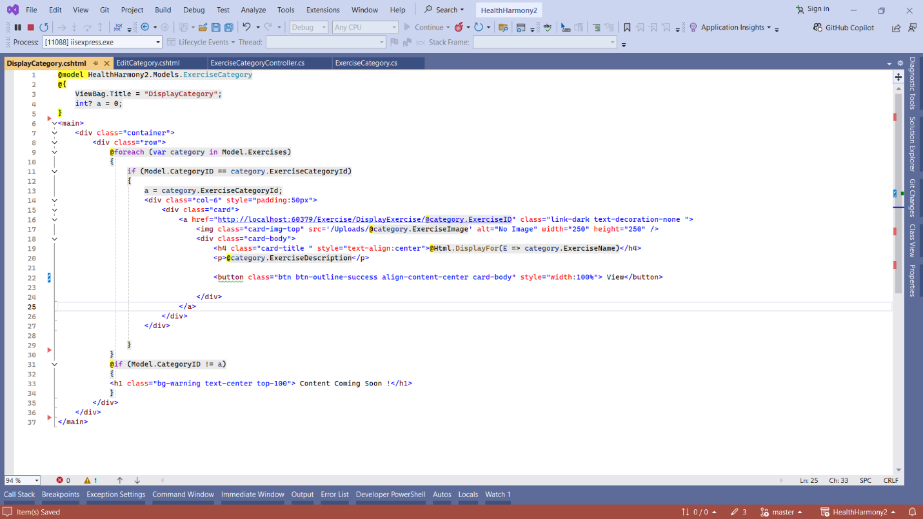

**OutPut**

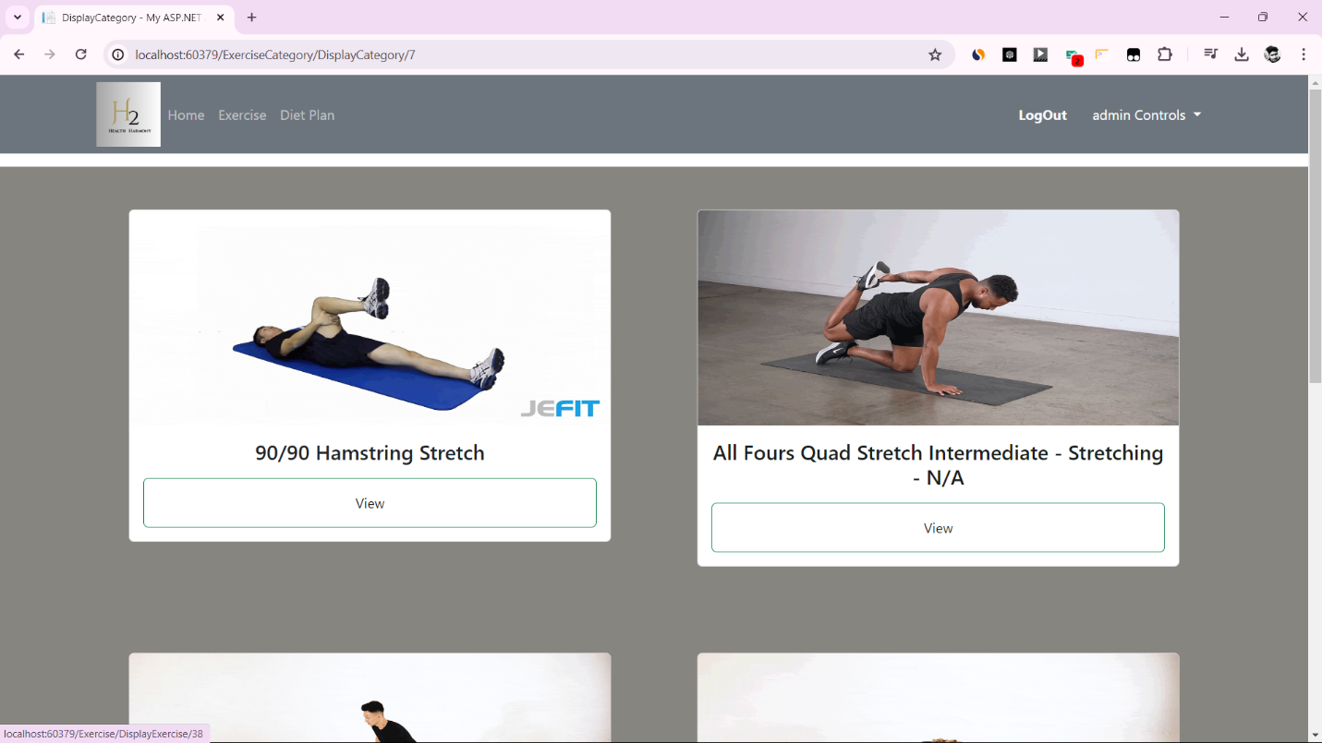

**Add Category view**

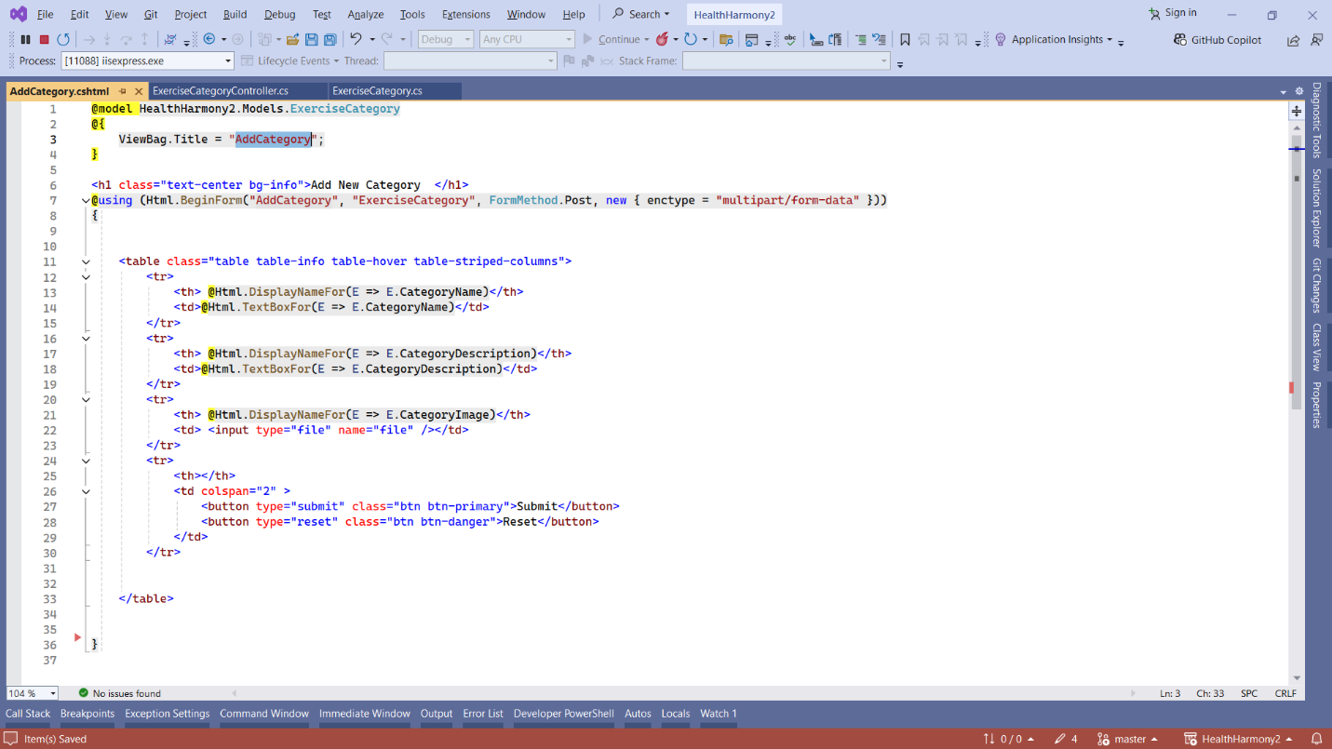

**OutPut**

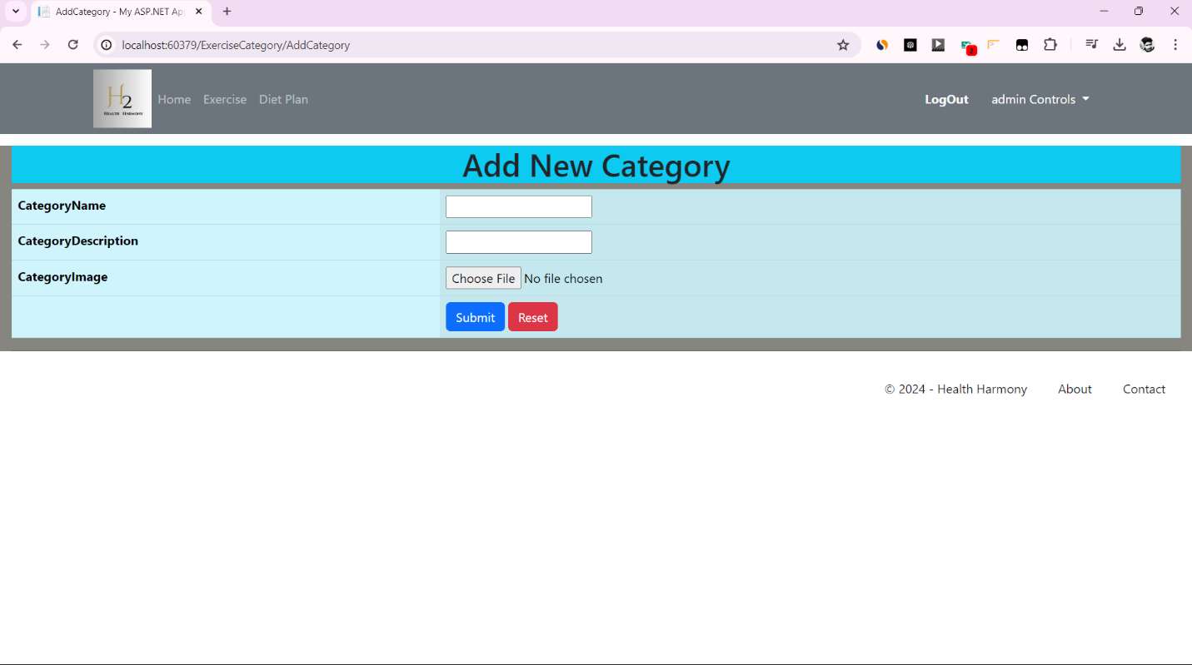

**Exercise Controller**

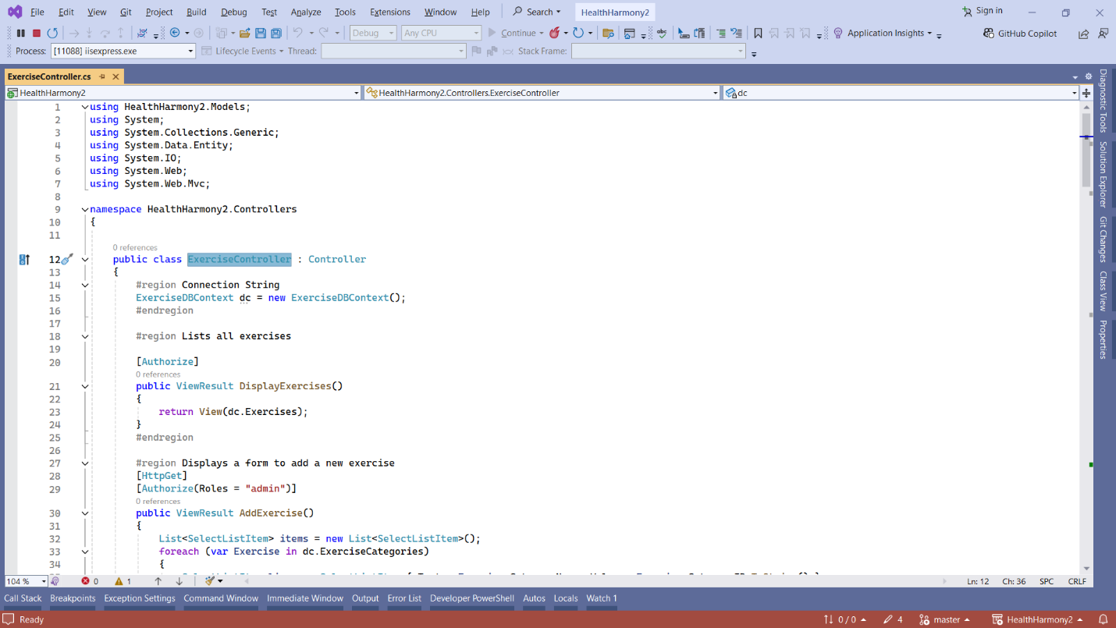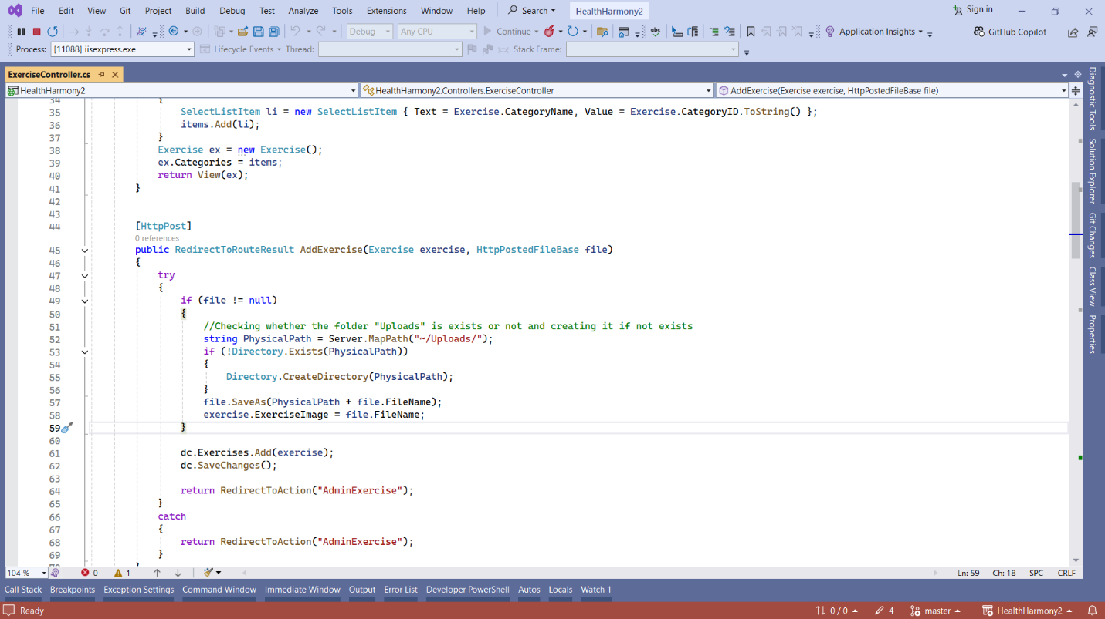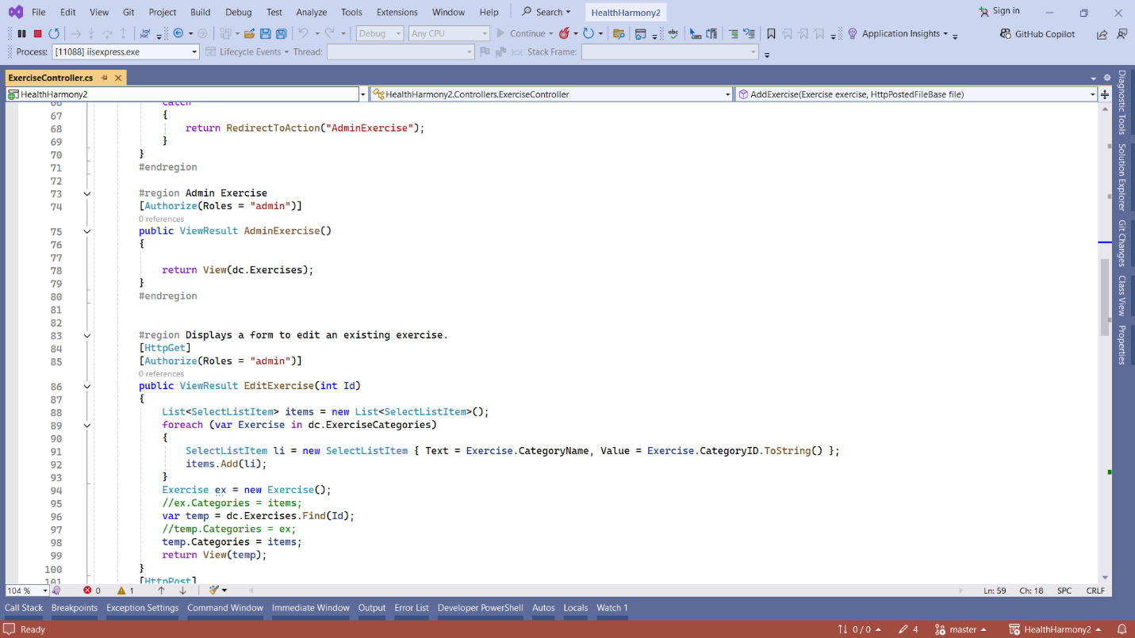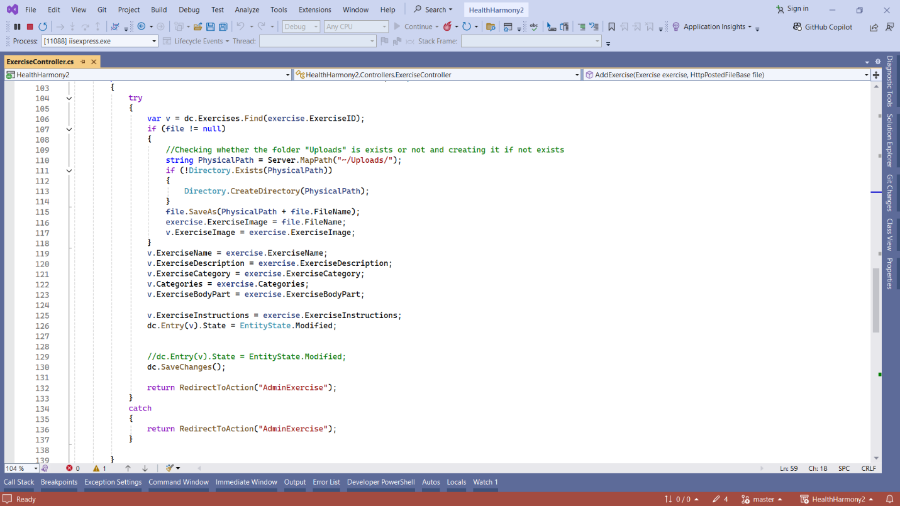

**Add Exercise view**

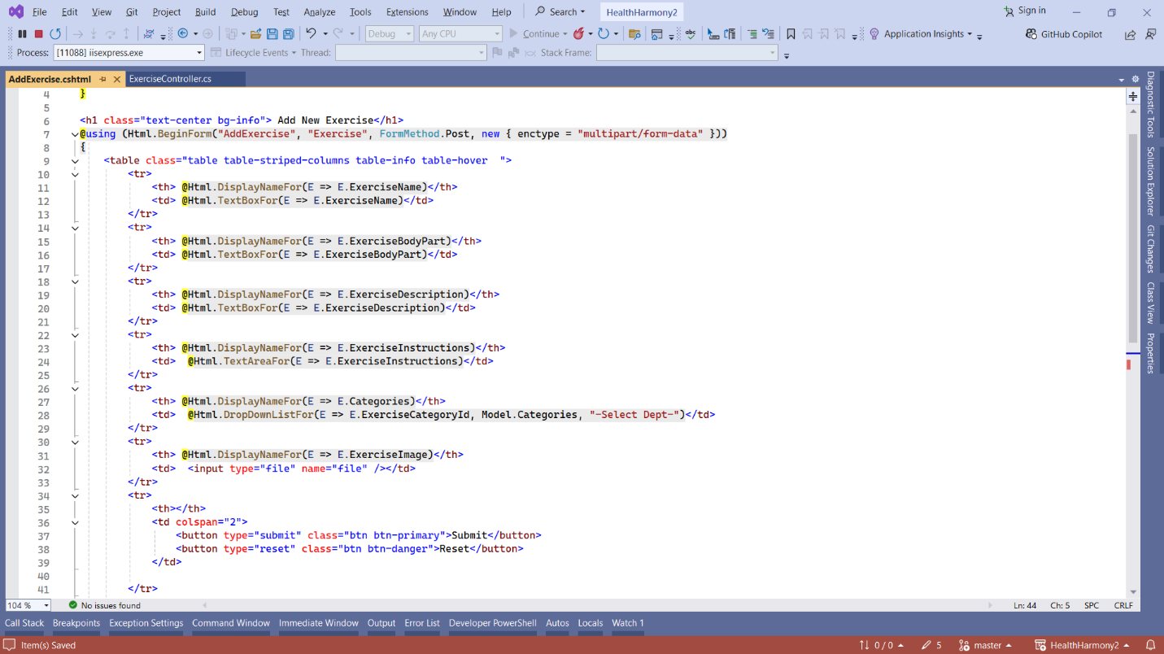

**OutPut**

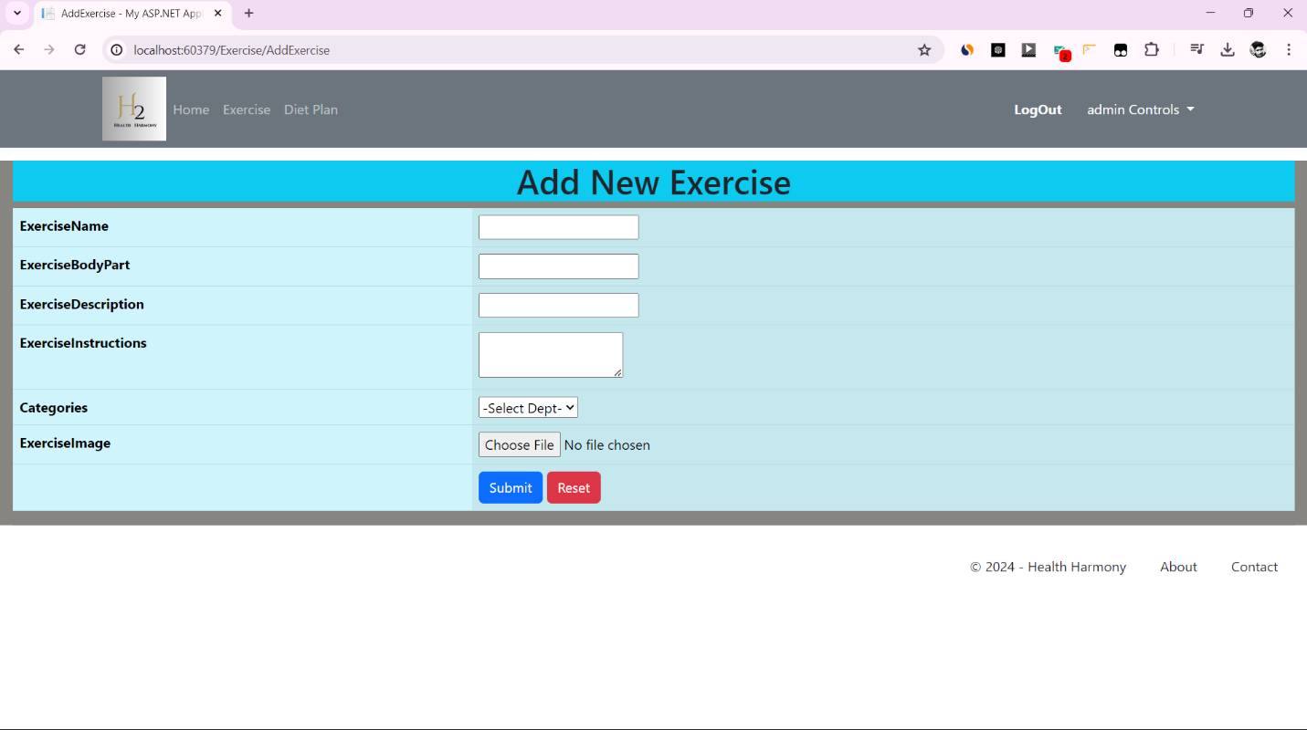

**Display Exercise view**

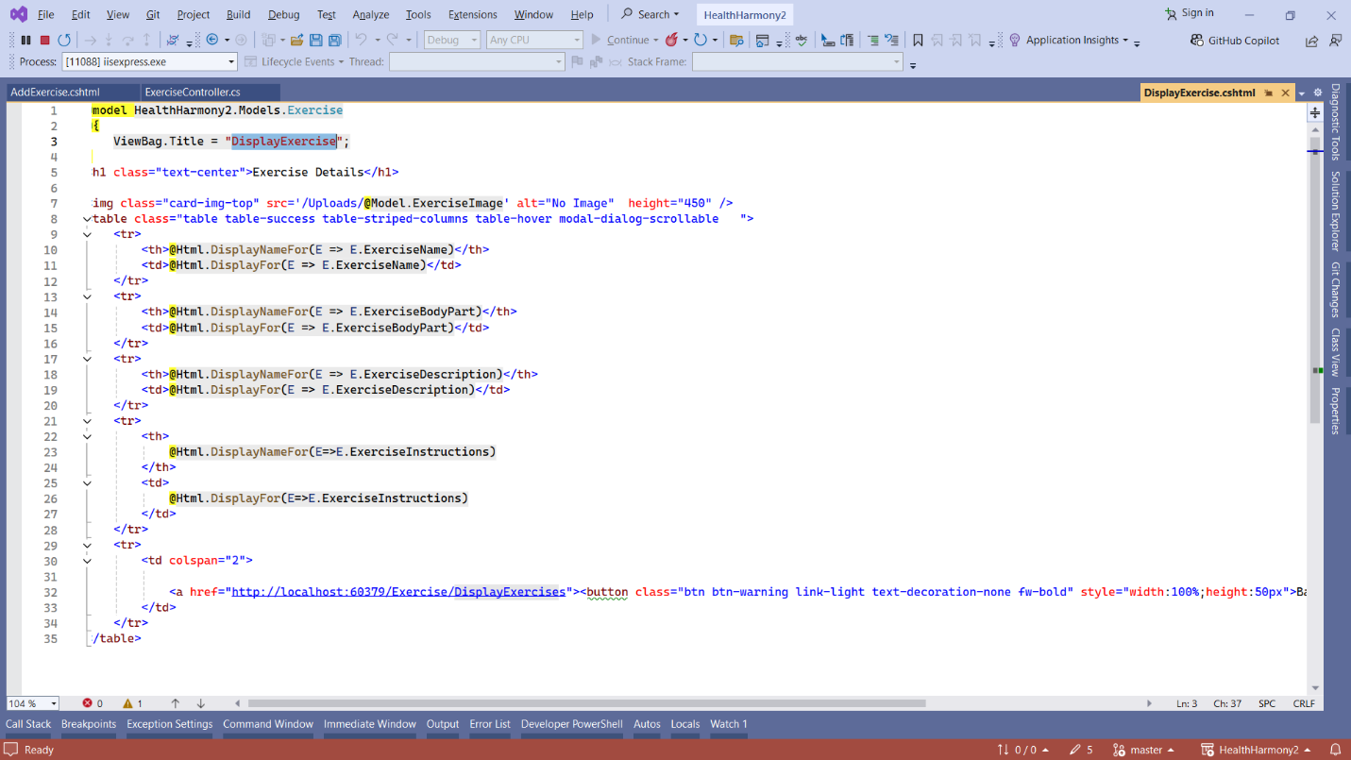

**OUT PUT**

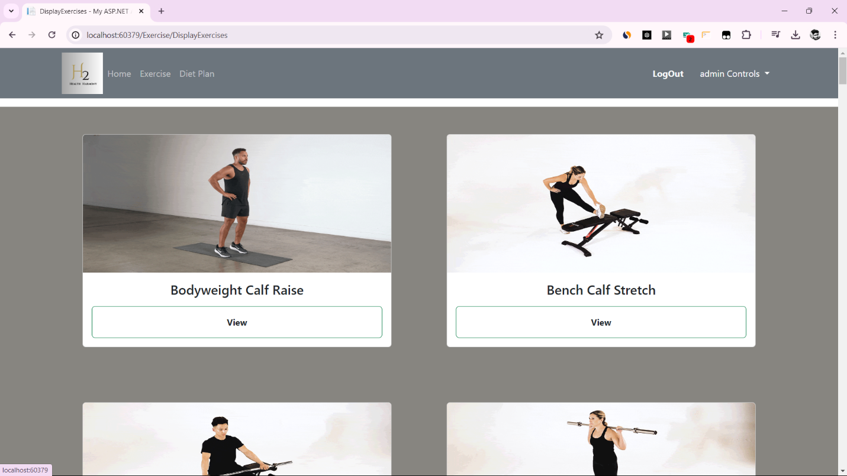

**Display Exercises View**

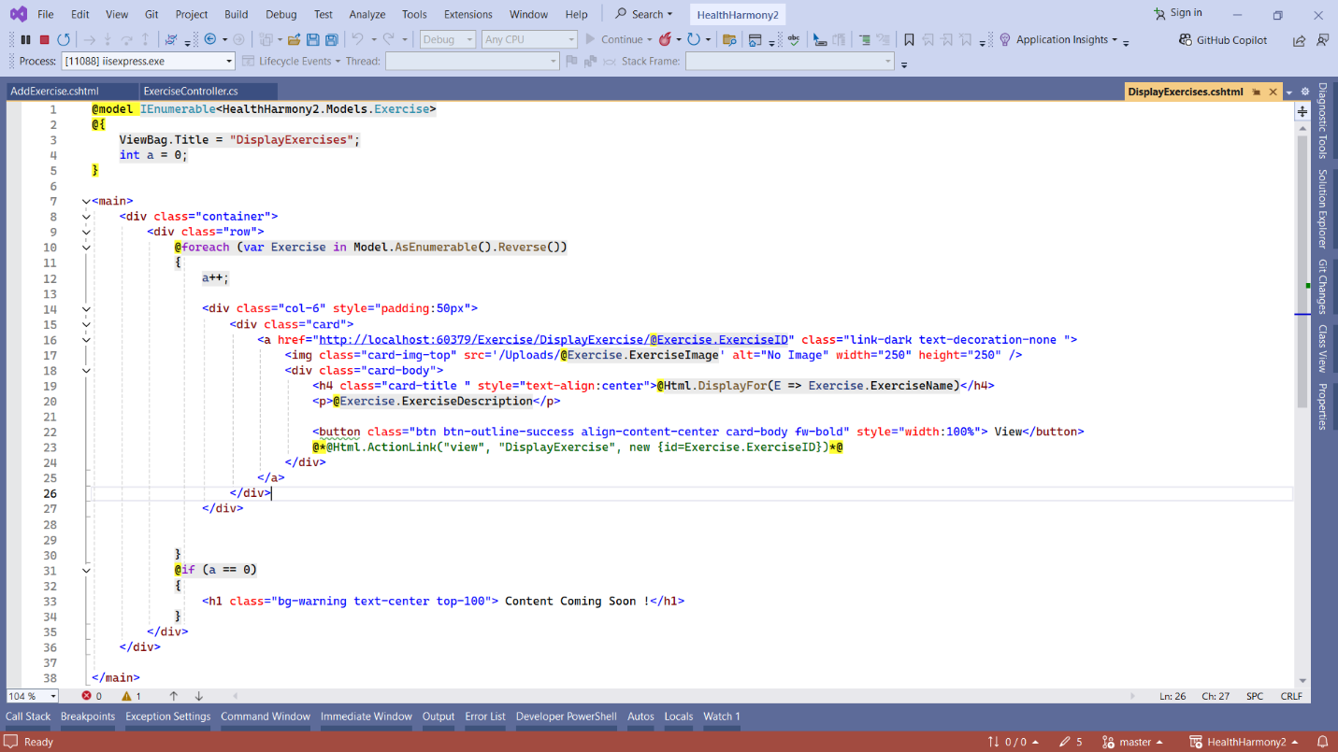

**Output**

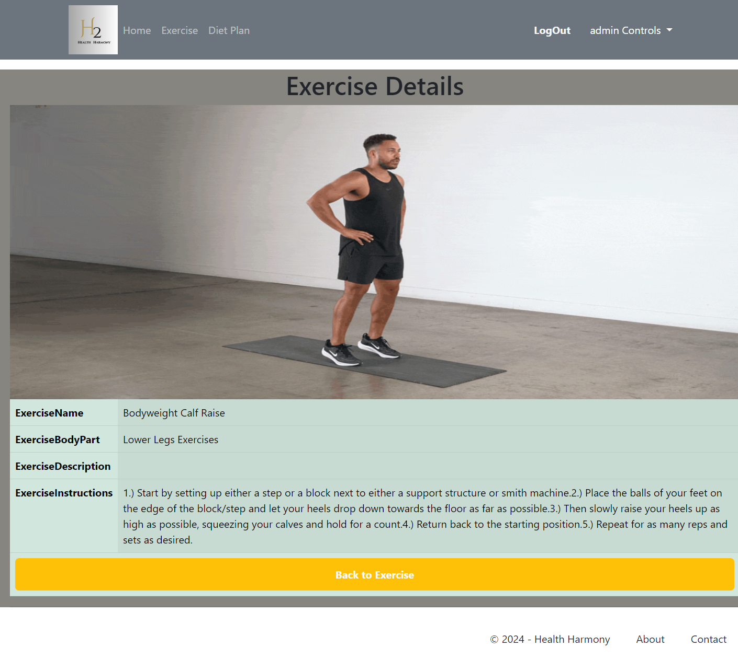

**DietPlan Controller**

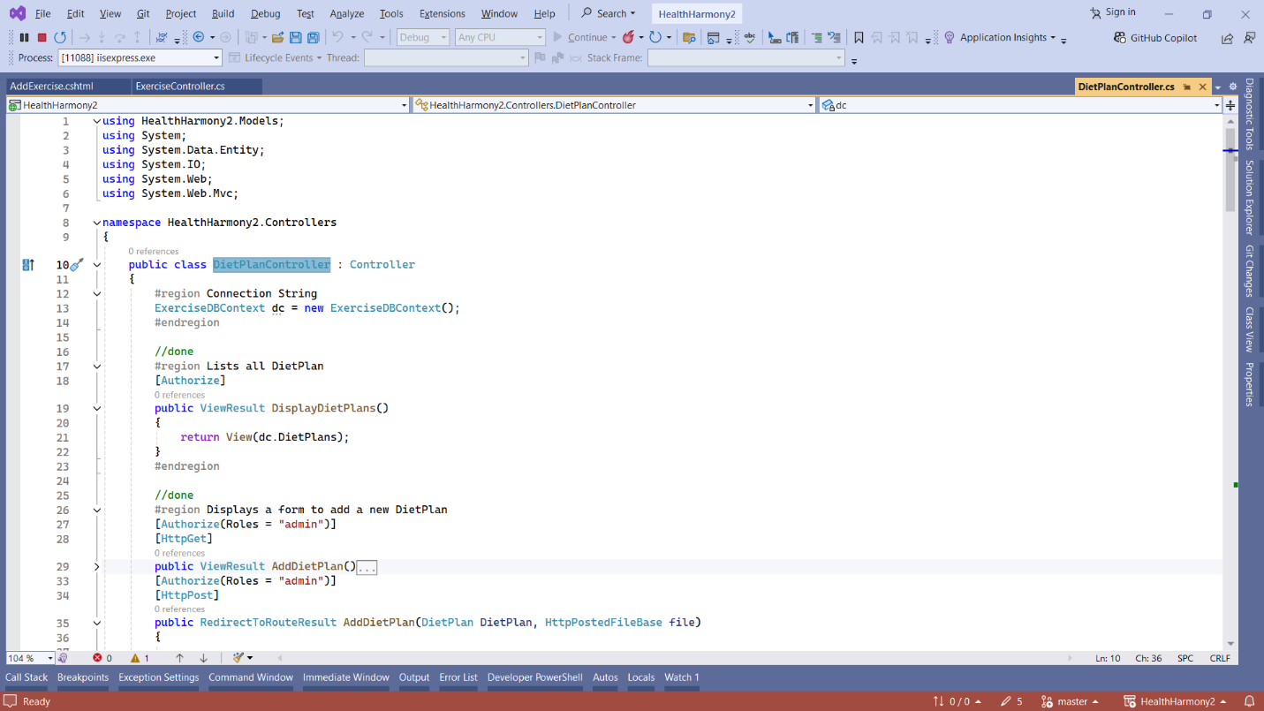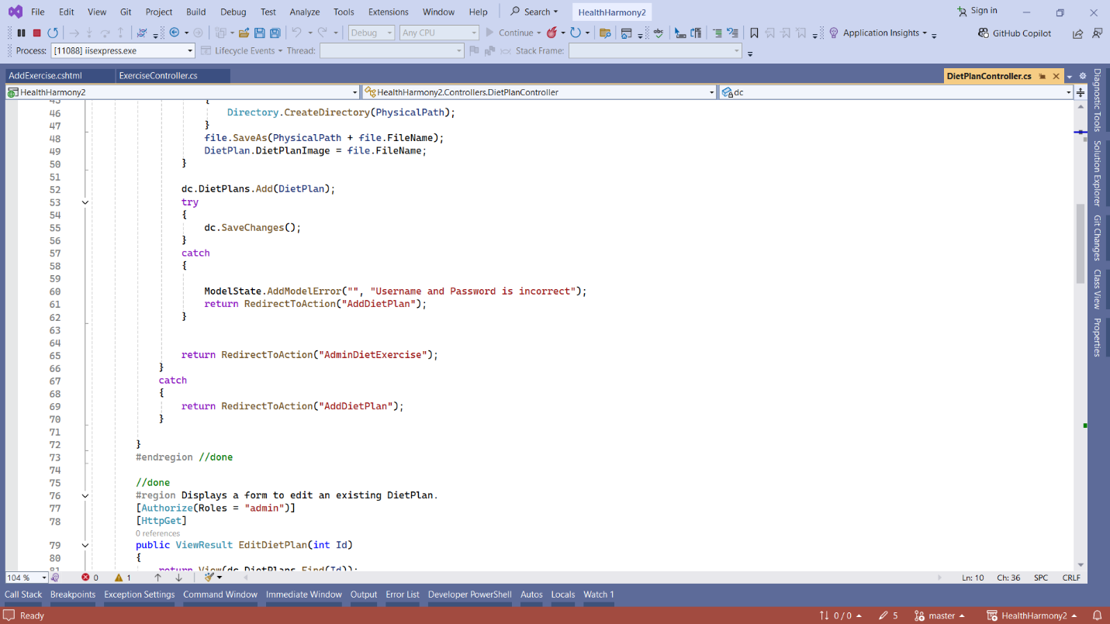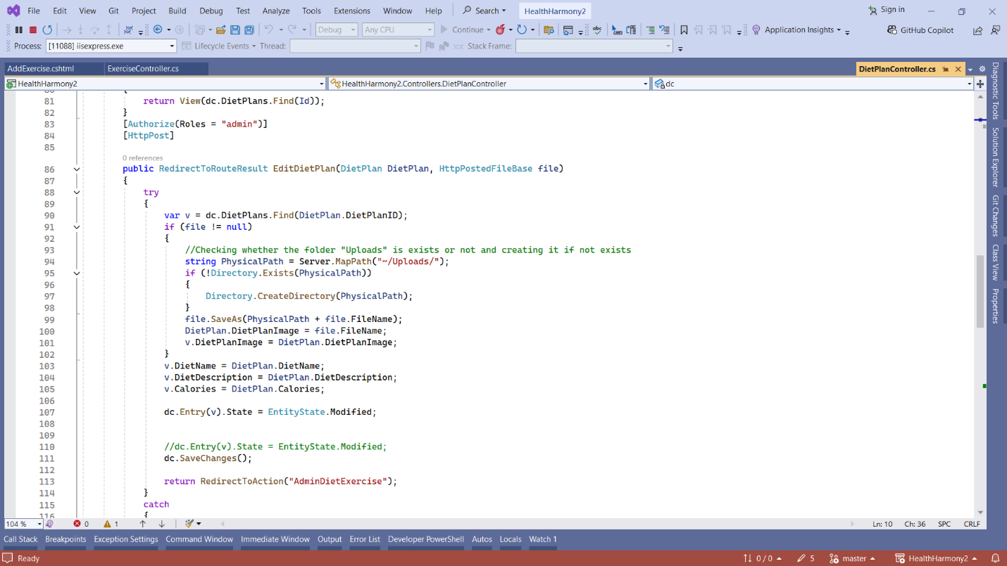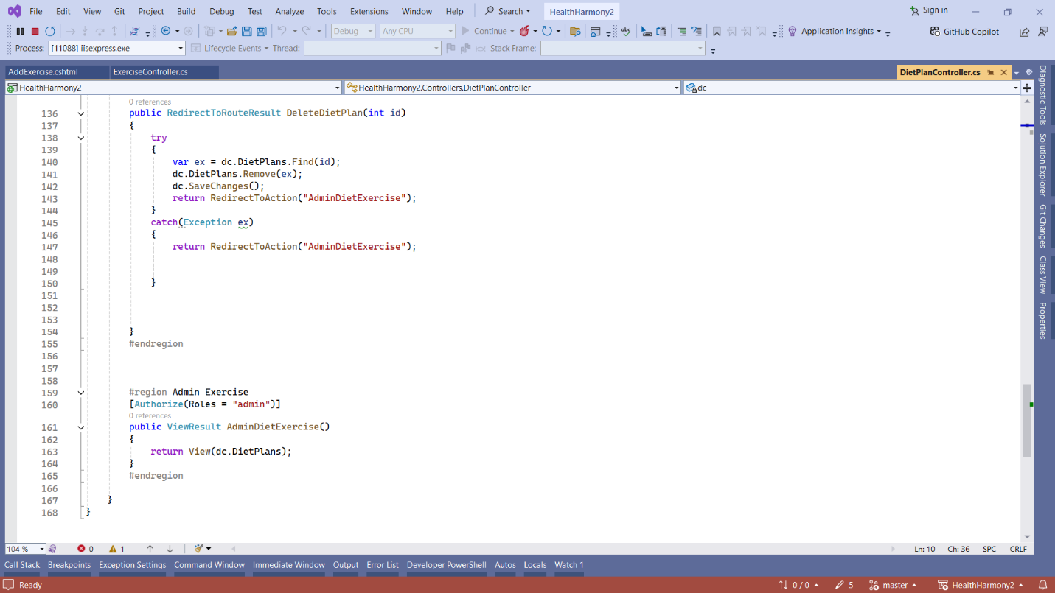

**Display DietPlans View**

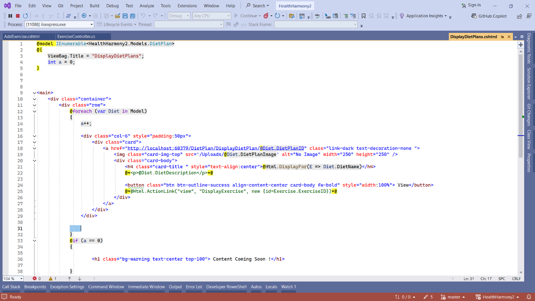

**Output**

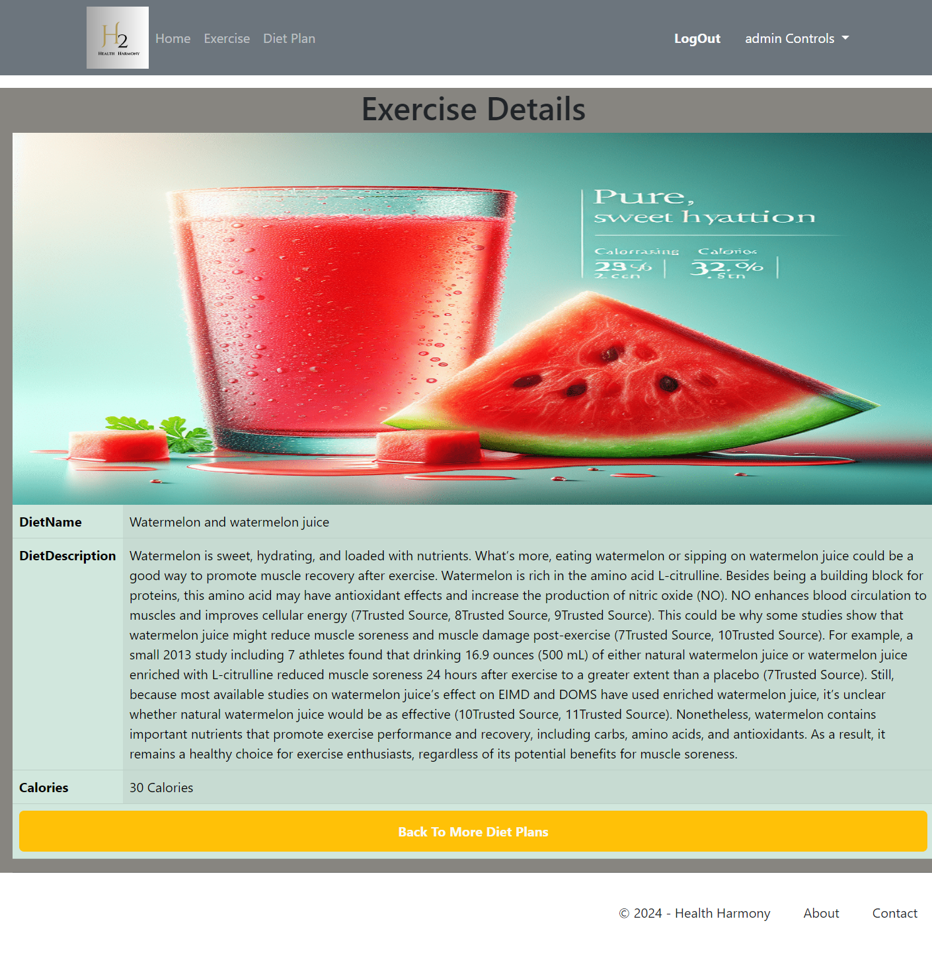

**Account Controller**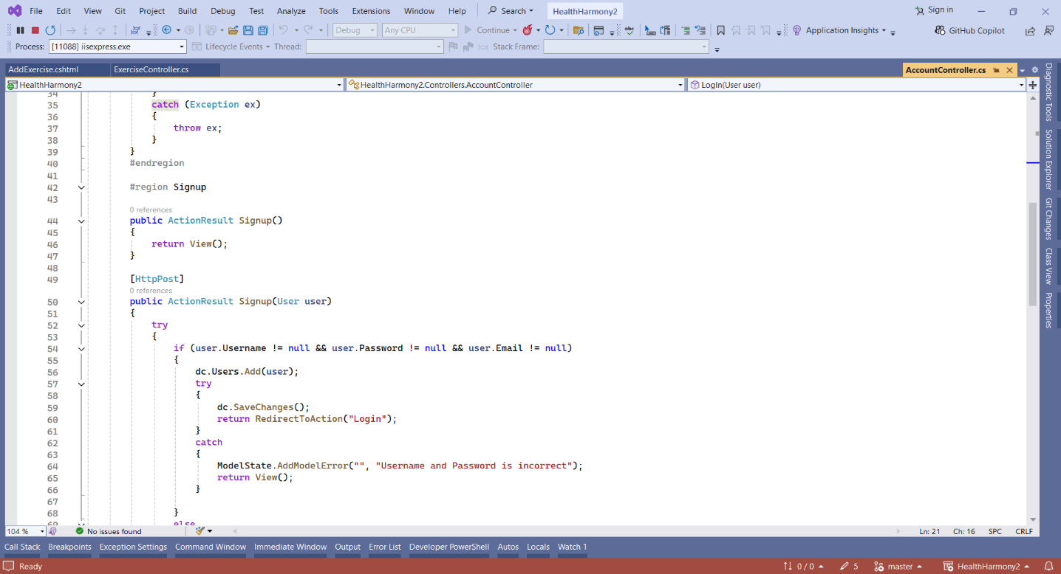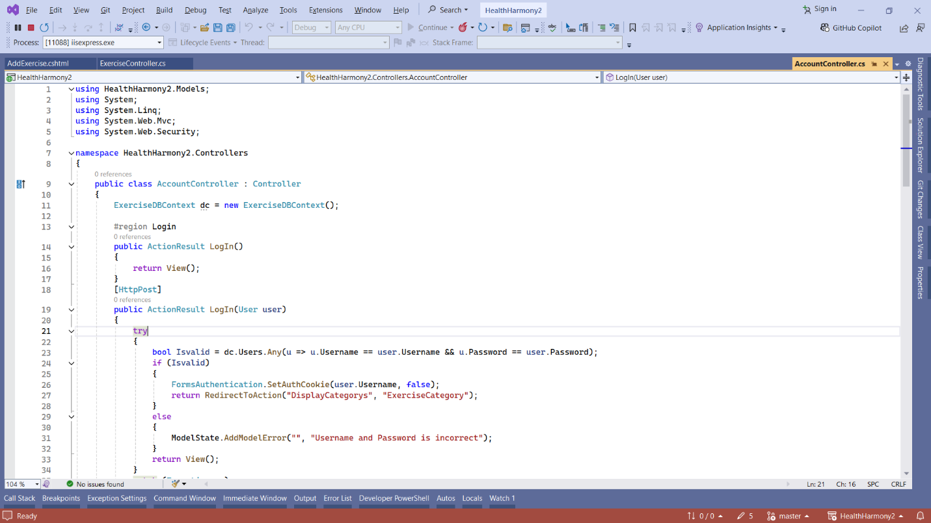

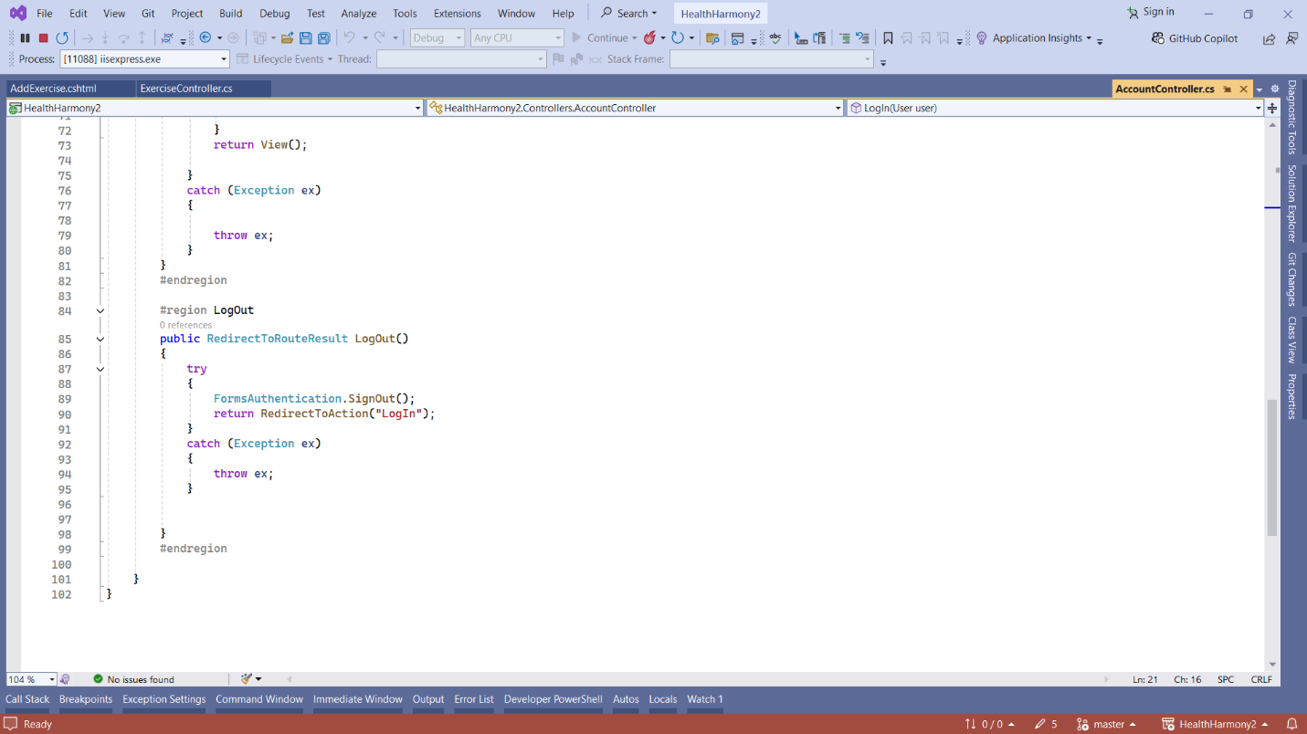

**LOGIN View**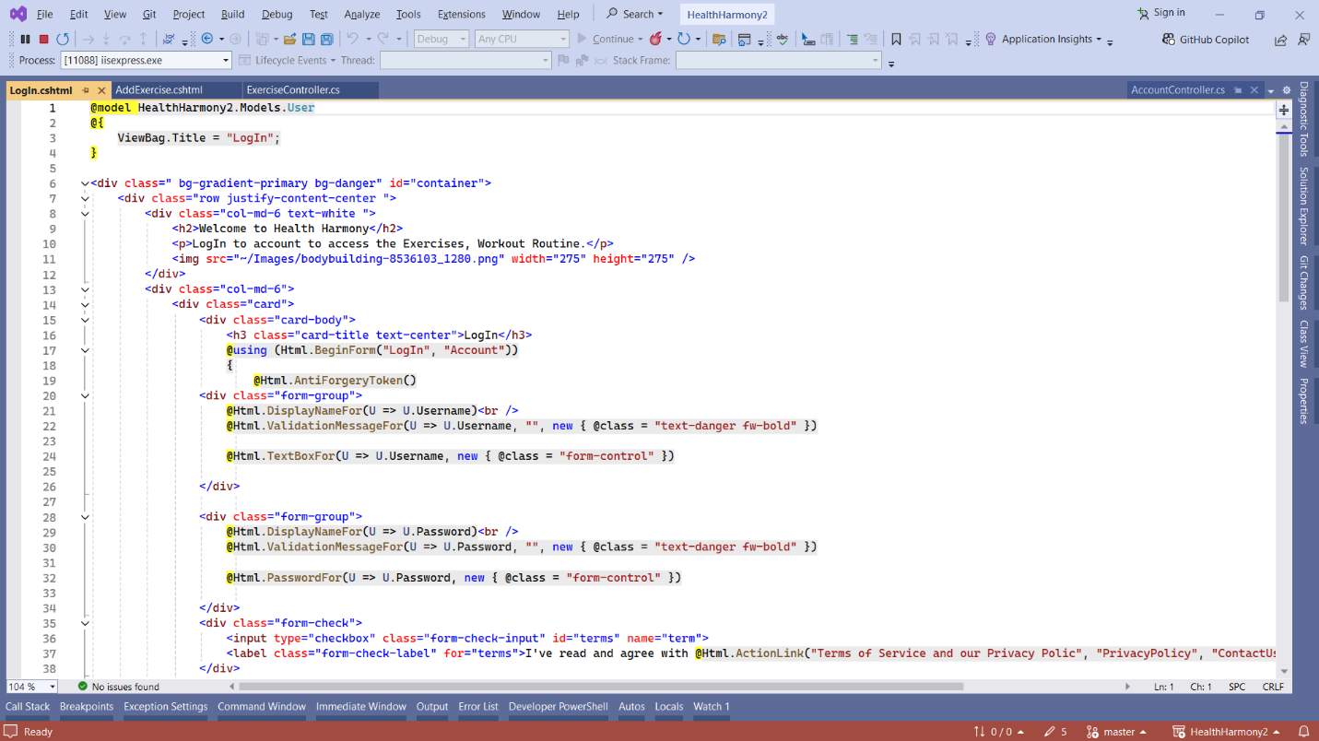

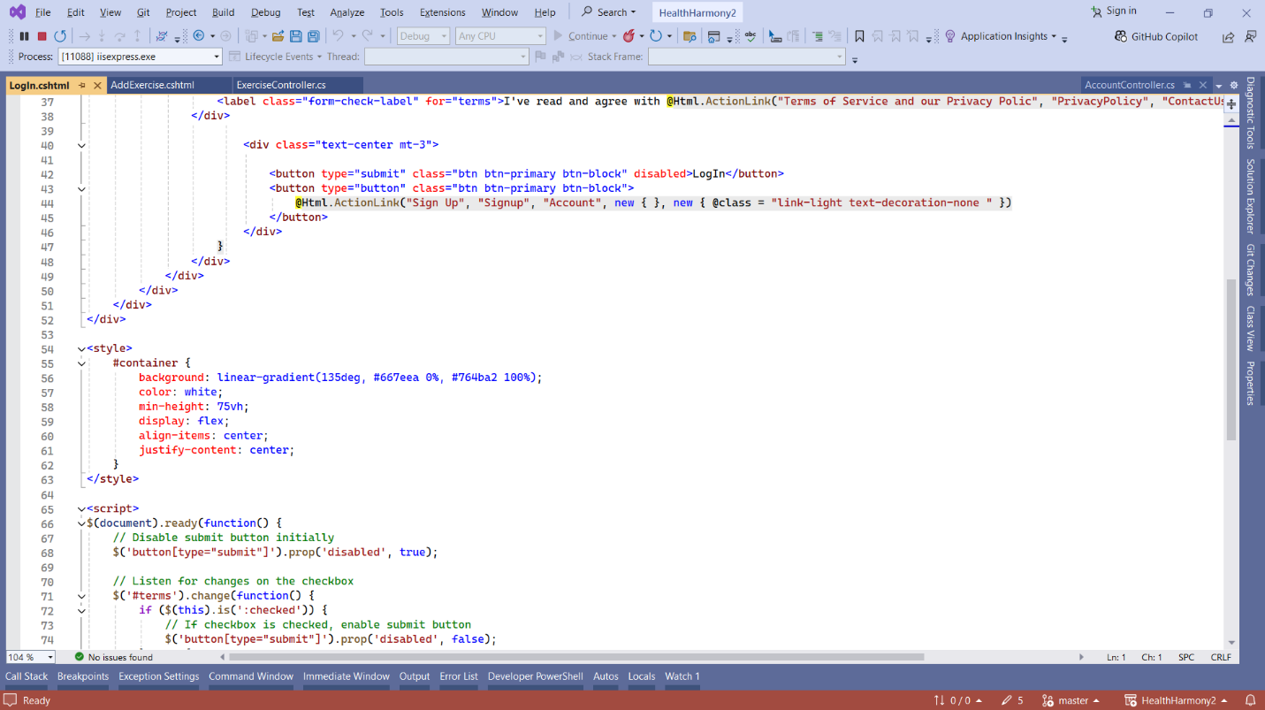

**OUTPUT**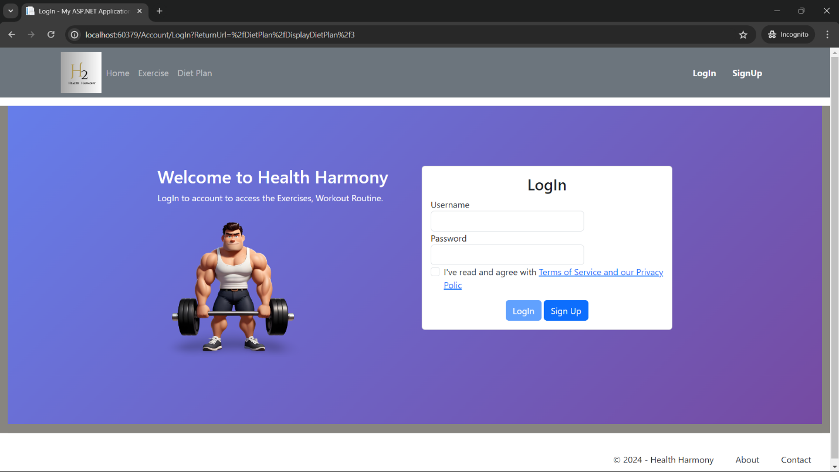

**SIGNUP View**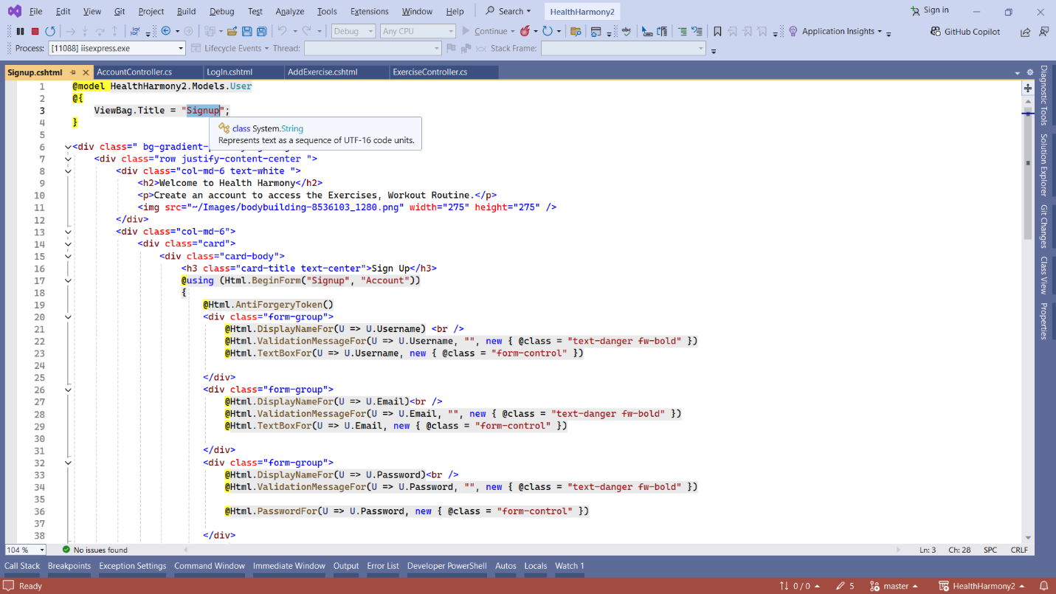

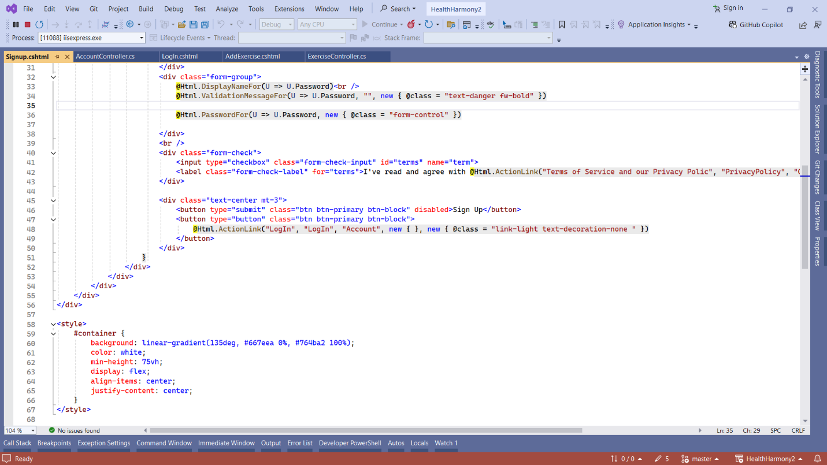

**OutPut**

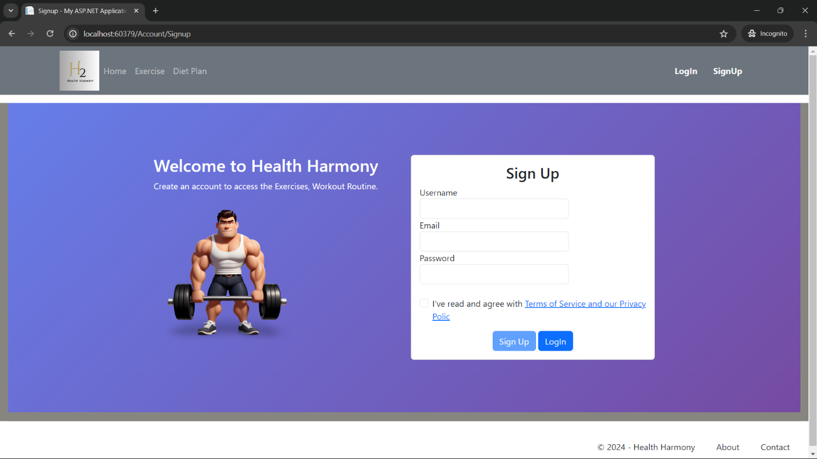

**ADMIN VIEW**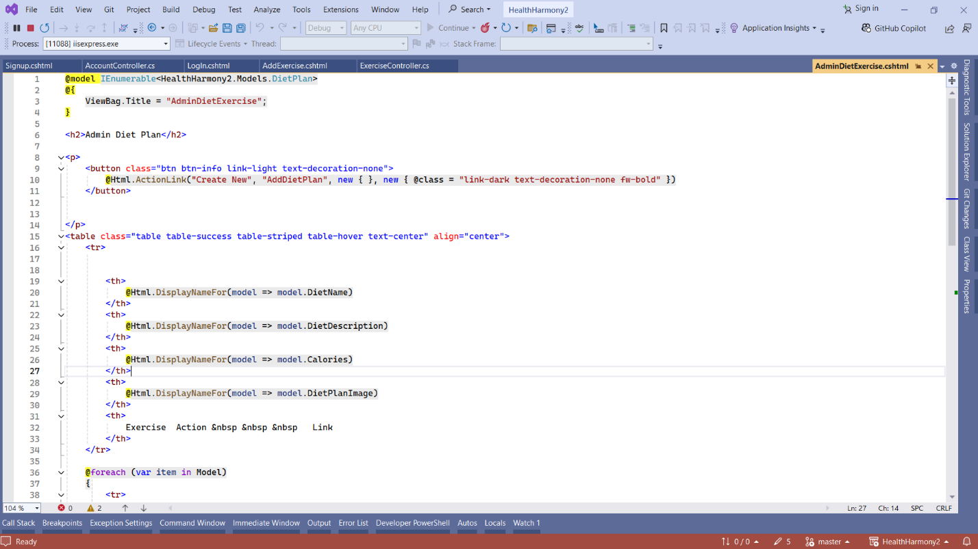

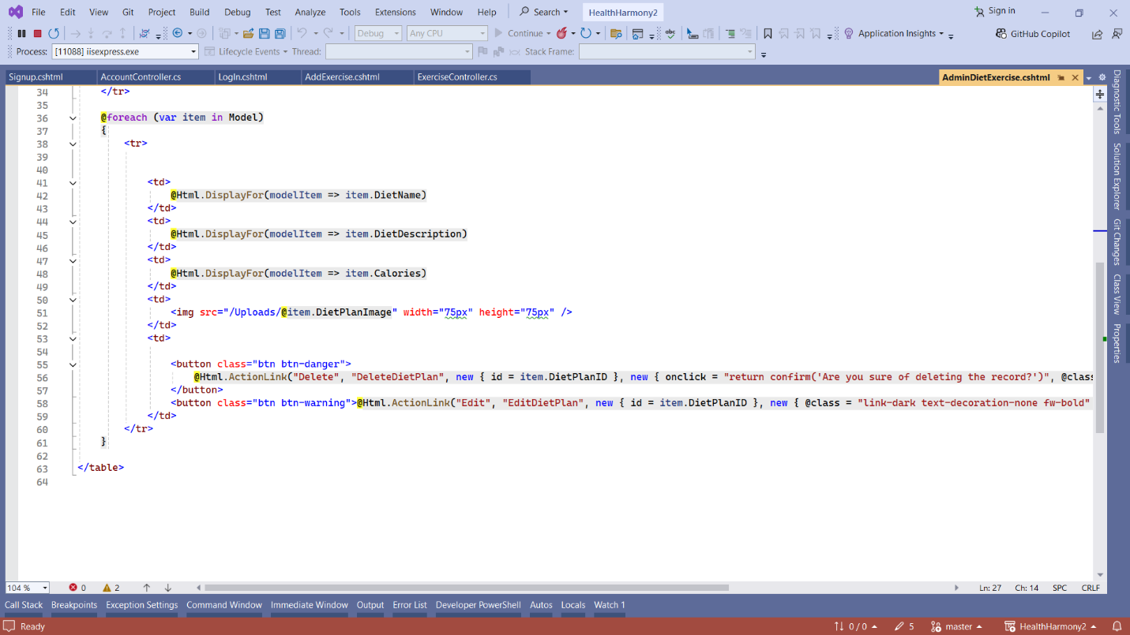

**OUTPUT**

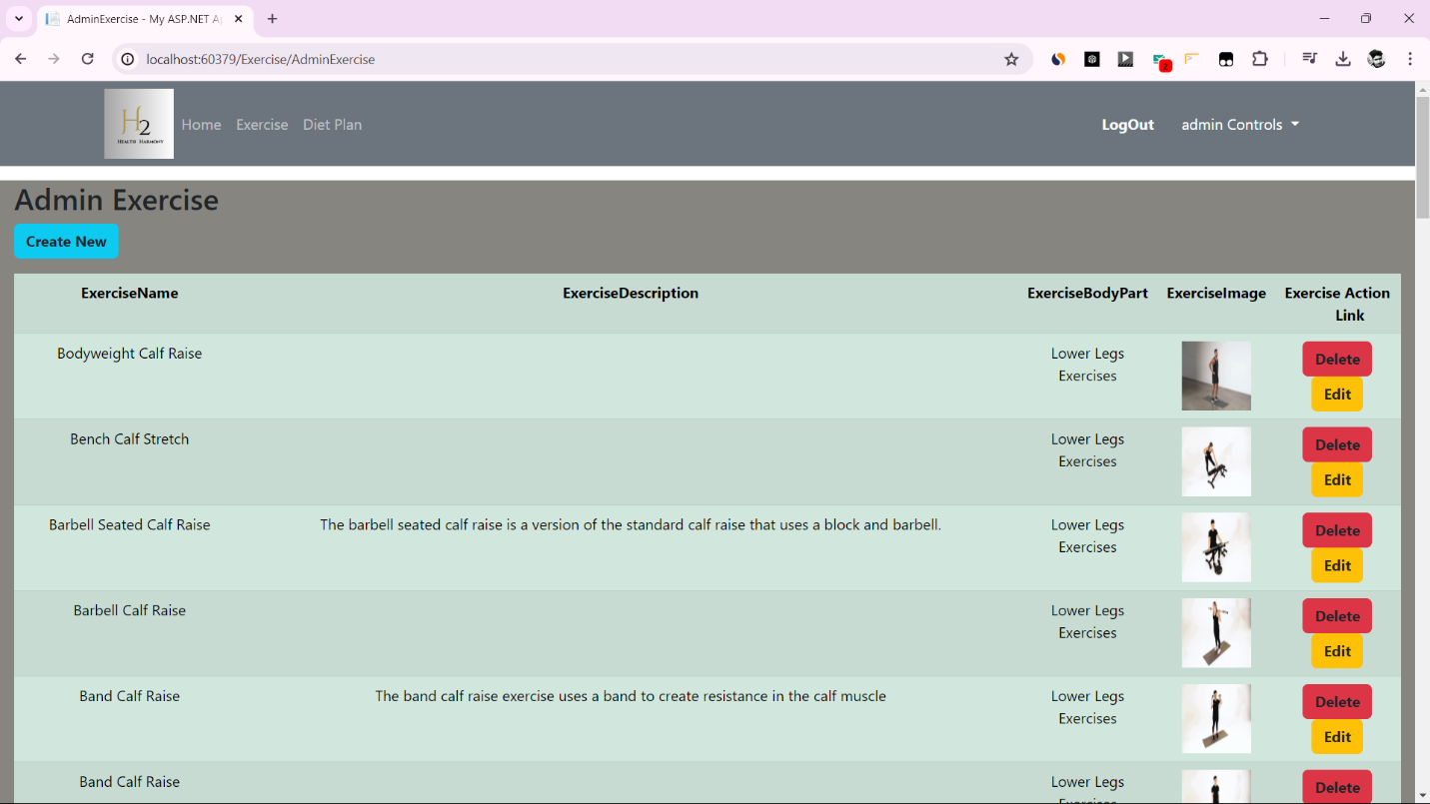

**SQL SERVER TABLES**

**Exercise Category Table**

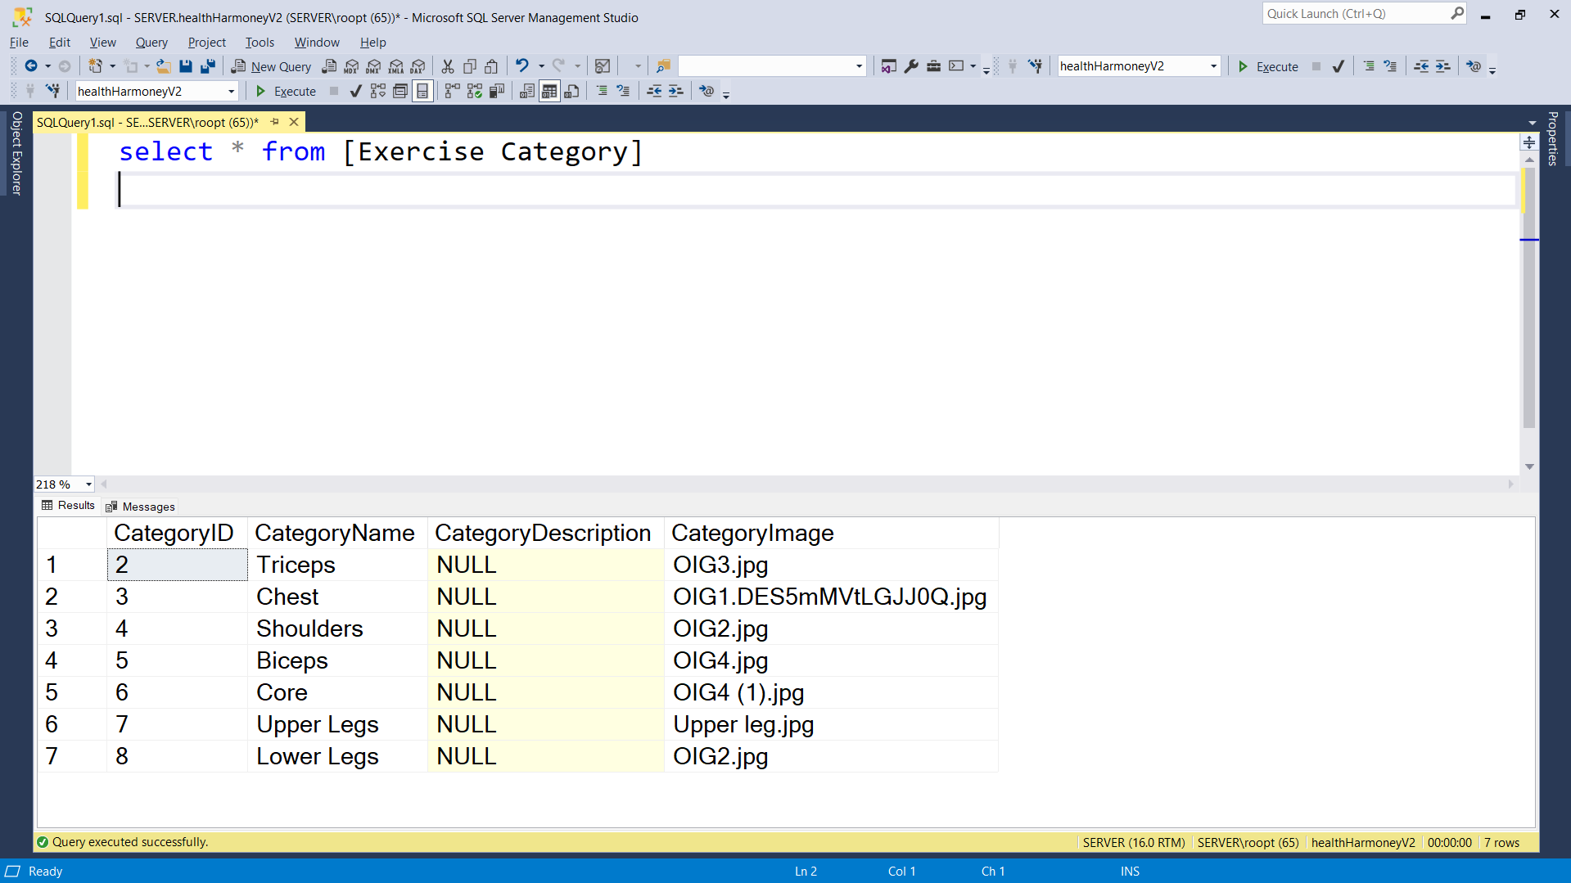

**Exercise Table**

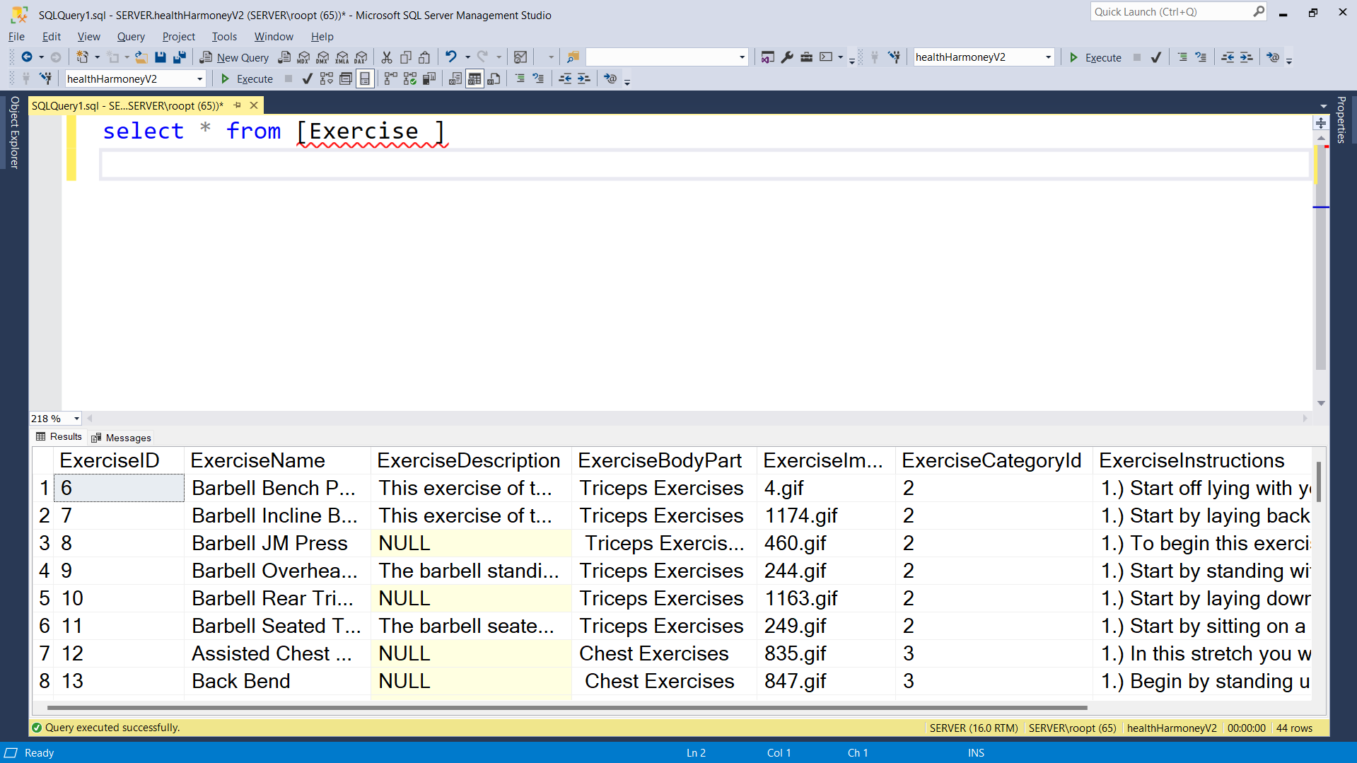

**User Table**

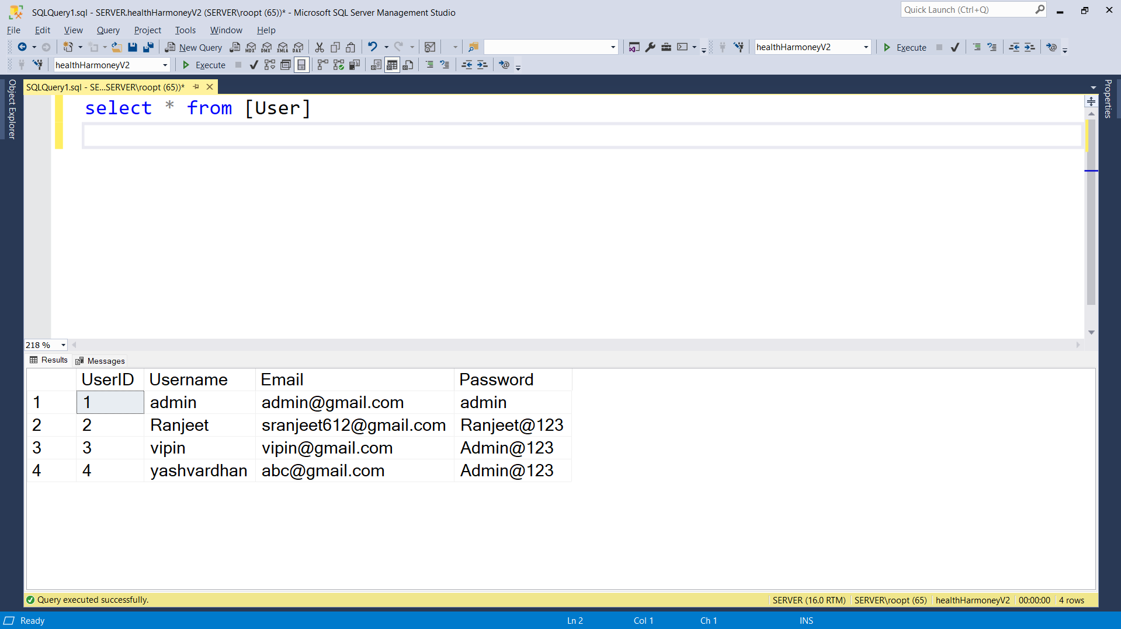

**User Roles Table**

